Reference links
docs | https://courses.datacumulus.com/downloads/certified-cloud-practitioner-zb2/
Contact AWS Support for help https://support.console.aws.amazon.com/support/home | aws account activated of feb-7-2025
acceptable usage policy – how to use AWS- we should not use to threaten other and we should not use AWS for fradulent purposes
https://aws.amazon.com/aup/
to download putty and putty gen softwares | https://www.chiark.greenend.org.uk/~sgtatham/putty/latest.html

Video status
Pending –practice attaching aws roles to Ec2 instances

About aws
Launched 2002 privately and launched in 2006 publicly

Why AWS /any adv cloud provider
AWS is one of the cloud service provider (if companies choose AWS then we)
Ex:- is power provider – telangana power distributor
When we are building house – we have 2 options
- producer power on our own by buying solar panels, generators, batteries
in this way companies like wells fargo/any comp needs to establish a data center buy buying land , buy physical computers &AC, power supply to those data centers
install os and create virtual machines… (everything should be managed by each company) and then on those machines we can install apps
others problems- buy and maintain hardware , giving maintainence contract to maintain that DC & networking
- take the power from govt and use it (simpler--- this is called cloud approach)
this is like a cloud provider where we will deploy apps in servers & those servers will be maintained by cloud providers
so with AWS, amazon people will create a huge data center with all hardware, AC, power supply.., so we can just deploy our apps into those machines
AWS/GCP Being cloud

Advantages
- Reduced infrastructure maintenance /Data center reduction (companies doesn’t need to maintain any physical infrastructure – cloud provider will maintain physical computer, power supply to them ..)
Ex:- in hyd we have AWS data center , WF / any small company if they want to deploy apps they don’t need to buy land & physical comp & all , just in AWS EC2 we can deploy appps into those linux machines
So with cloud every company doesn’t need to maintain their own data center
- Increased availability and reliability
- Scalability of an on-demand resource
- Lower operational costs
- We don’t need to do patching and updates to that hardware – everything cloud provider will take care
Note:- root user only should create other iam users
So summary is , every company instead of maintaining their own private physical data center , better to take services from cloud providers, ex;- AWS has already built an excellent data center
We can just go and use them and install our apps on their linux machines

Hybrid cloud – if any company has both data center and some apps in cloud, then it is called hybrid cloud
A Hybrid Cloud refers to a computing environment that combines a private, on-premises data center with cloud services. This setup allows businesses to run certain workloads in their physical data center while leveraging the scalability, flexibility, and cost-efficiency of the cloud for others. Hybrid cloud enables seamless data and application integration between the two environments, allowing organizations to balance performance, security, and cost according to their needs.

Problems with traditional data center (DC)
- No elasticity – bec if we would have built DC with 200 comp, if after some months if there is more traffic to,
then we cant buy physical computers at that moment right?
Where as in aws- based on the load we can spin up the instances (Bec AWS will maintain huge infrastructure)
So hence our physical data centers are not elastic

Terminologies
Data center | A Region and a Data Center are related but distinct concepts within the Amazon Web Services (AWS) infrastructure. Here's a breakdown of their differences:  Data Center:  - A data center is a physical building or facility that houses a large number of interconnected computer servers, storage systems, networking equipment, and other IT infrastructure.  - It includes the necessary infrastructure to support these components, such as power supplies, cooling systems, security measures, and high-bandwidth internet connectivity.  - AWS owns and operates numerous data centers globally. These are the physical locations where your applications and data reside when you use AWS services.  - Each AWS data center has redundant power, networking, and connectivity to ensure high availability.
server less | serverless means developer don’t have to create and manage servers anymore as aws manages server, serverless means managed by AWS,just deploy code  dynamo db, Athena, S3,fargate is serverless  means we don’t need to create this db instance, aws will create this db instance and aws only will manage

Region or place/city = an area like hyd region  Data center =avaliablity zone  AWS region = cluster of data centers  A region must have:  - 3 or more physically separate data centers (AZs)  - Located close enough for ultra-low latency  Most AWS services are region scoped  ex:- in hyd region there are multiple Data centers  (Ec2-iaas, elastic bean stalk-paas, lambda-faas)  they have 10+ region caches  AZ= single Data center  AZ = Different tech parks/buildings in that city  One Region does NOT span multiple cities far apart  - Hyderabad Region  - AZ-1 → Data center in Gachibowli  - AZ-2 → Data center in Madhapur  - AZ-3 → Data center in Shamshabad  👉 These are:  - Physically separate locations  - But connected with high-speed network  so In india there are 2 AWS regions, hyd and mumbai,  Region Code  Mumbai ap-south-1  Hyderabad ap-south-2 | 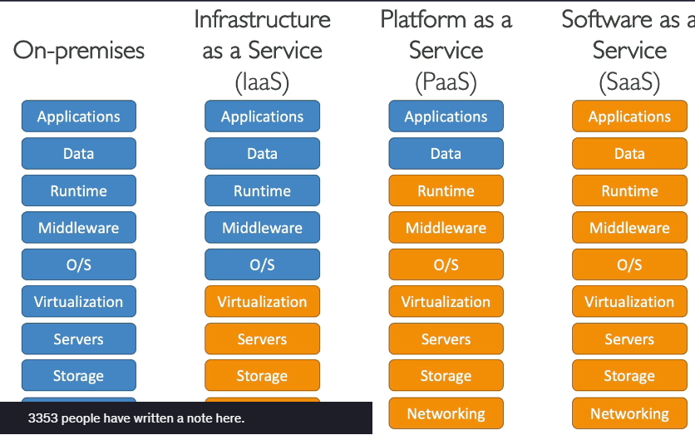  Region wise services can be checked here https://aws.amazon.com/about-aws/global-infrastructure/regional-product-services/  some services are available in all dc, but some services are only available in some regions alone  ex:- new services will only be available in new region  Why multiple data centers in same city?  Because of failures:  Example:  - Power outage in Gachibowli ❌  - Flood / fire in one area ❌  👉 Other AZs still work ✅
principle | means who is asking for access

AWS Regions
Aws has regions all over the world
AWS region = cluster of data centers
Most AWS services are region scoped
AZs are NOT data centers: An Availability Zone is more than one data center. It's a collection of data centers with independent power, cooling, and security.

How to choose a AWS region
Compliance :- Compliance with data governance and legal requirements: data never leaves a region without your explicit permission
• Proximity to customers: reduced latency (so choose a data center which is nearer to your location)
Available services within a Region: new services and new features aren’t available in every Region
Pricing: pricing varies region to region and is transparent in the service pricing page
AWS availability zones
availability zone = a data center
1 region = cluster of data centers (cluster of availability zone) all are clustered to protect against natural disasters
- Each availability zone (AZ) is one or more discrete data centers with redundant power, networking, and connectivity •
- They’re separate from each other, so that they’re isolated from disasters •
- They’re connected with high bandwidth, ultra-low latency networking

IAM (Identity access and management)
Don’t use the root account except for AWS account setup , so create iam users and login as iam user instead of root user
IAM is a global service (so you cant select a REGION)- global means available every where
In IAM principal is the one who wants access
A principal can be:
- An IAM user.
- An IAM role.
- An AWS service.
- An AWS account.
- In some cases, even an anonymous user.
when an IAM policy grants permissions, it's granting those permissions to a specific principal.

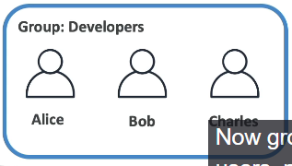  - groups contain only users not other groups  - a user can belong to multiple gropus –same like whatsapp group  - and make sure every user should belong to a group | Generally a root user can create other users (IAM users)  in real time project, we all mostly login with IAM user name and pass (some times, 1 person can be in 2/many groups )  All the users will be in a group & a policy will be applied on that group  IAM policy is a json file which defines the policy (which user should get which access.. all these details will be present in that json)  Here principal refers to an entity who is requesting access to an AWS resource.( "Who is making this request?")  Essentially, it's who or what is asking for permission to perform an action.  Ex:- in real time an Ec2 also can ask permission for EKS  every IAM user will have alias & user name 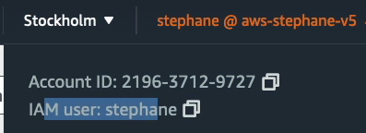
analogy | 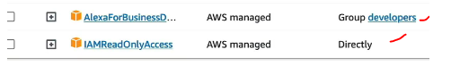  like how a person have many lic policies in real life  AWS user can also have many policies as the person can be in many groups,(gen a policy will be applied on a group)  and we can even see bec of which group he have that policy  And above says, always keep the users in a group and attach a policy on a group, instead of  attaching policy directly on iam user (as per 2nd line in image )

IAM Policy
An IAM Policy is a JSON document that defines permissions: what actions are allowed or denied on which resources.(whom to give which access)
Can be attached to:
- IAM Users (if we cant keep users in a group, then we should apply policy directly on a person)
- IAM Groups (we will keep the users in a group and we will attach the policy on that group )- best and common in real time
- IAM Roles (once this policy is applied to a role then we will apply that role to an EC2 instance)

sample IAM policy
{  "Version": "2012-10-17",  “Id”: “p1” (this is identifier for that policy)  "Statement": [  {  "Sid": "AllowDeveloperActions",  "Effect": "Allow",  "Action": [  "ec2:Describe*",  "ec2:GetConsole*"  ],  "Resource": "*"  “principal”: {  “AWS”: [“abcd”]  }  },  {  "Effect": "Allow",  "Action": "ec2:RunInstances",  "Resource": [  "arn:aws:ec2:*:*:subnet/subnet-subnet-id",  "arn:aws:ec2:*:*:network-interface/*",  "arn:aws:ec2:*:*:instance/*",  "arn:aws:ec2:*:*:volume/*",  "arn:aws:ec2:*::image/ami-*",  "arn:aws:ec2:*:*:key-pair/*",  "arn:aws:ec2:*:*:security-group/*"  ]  }  ]  }  here this policy will give ec2 access to all users in that grp | this is the policy that will be applied on a group (some members in that group)  so now all these users present in this group will get access to EC2 instances  here "Resource": "*" means on which & all resources these access are are applicable  Policy  these policies define the permissions to the users , this policy can be applied on a group and it can be applied on a individual person also and we can even apply a policy on EC2 instance also  Inline policy  means policy attached to that particular user bec since he might not be in any group, so we would have directly attached a policy to that user alone  - So policy can be attached to a group or it can be attached on a single person also (its always best to attach policy on a group and add users to group)  here principal means who is asking for the access  Action:- here action defines what he can perform  assignment:-  add users to the group and apply a policy to the group  remove the users from group and add a inline policy on that user alone  see the existing policy json documents  ex:- if we attach a “IAMReadonlyAccess” policy on a group / on a user then he can get all get Accesses  put a policy on a user

- Within IAM policies, the "principal" element specifies who is allowed or denied access to a particular AWS resource
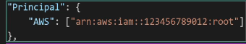
Groups (Groups are containers for users) | policies (Policies define what those users (or groups) can do.)
Once a user is created, we should keep every user in 1 group  we can attach some policies to a particular group  Any user within the group inherits the permissions defined in the attached policies.  • IAM groups are collections of IAM users. They simplify the process of granting permissions to multiple users simultaneously.  • Essentially, they're a way to organize users who require similar access levels  in real time all users will be in a group like in wells fargo Doe.CODI.Developer  in case of single User /Ec2 instance, instead of keeping that single user in the group and applying policy on a group, we can directly attach a policy to that user alone | - IAM policies define permissions. They determine what actions an IAM entity (user, group, or role) is allowed or denied to perform on AWS resources.  - Function:  - Policies are JSON documents that specify permissions.  - They can be attached to IAM users, groups, or roles.  - They define granular control over AWS resources, specifying allowed actions, resources, and conditions.  - Key takeaway:  - Policies are for permission definition.  in real time, we generally apply a policy to an Ec2 instance or to a single user

And with that user can perform only limited tasks which he is entitled to do

Access keys, CLI, SDK
To access AWS we have 3 options
- AWS Management Console (protected by password + MFA)
• AWS Command Line Interface (CLI): protected by access keys
• AWS Software Developer Kit (SDK) - for code: protected by access keys
AWS SDK = aws language spec libraries, with this we can access and manage AWS services programatically
AWS has SDK for evey language – js, python, java

Access Keys are generated through the AWS Console
• Users manage their own access keys
• Access Keys are secret, just like a password. Don’t share them
• Access Key ID ~= username
• Secret Access Key ~= password

AWS CLI commands
aws –version
aws iam list-users

IAM roles("Who you are temporarily")
An IAM Role is an identity that you can assume temporarily to get a set of permissions.
- EC2 instance accessing S3
- Lambda function accessing DynamoDB
- Cross-account access
- Federated user (e.g., Google, AD) logging in
✅ Key Properties:
- No username or password
- Can be assumed by:
  - AWS services (like EC2, Lambda)
  - IAM users
  - Federated users or external identities
- We should apply policies on a iam role and we will apply that IAM role on a EC2 instance– then that EC2 can perform actions defined in the policy
🔁 Think of it as:
A jacket of permissions you wear temporarily.
Once worn (assumed), you can do what that role allows.

Some AWS service will need to perform actions on your behalf (ex:- EC2/java code wants to put files to S3 bucket, then we should give some service account cred/access keys and put those id in roles)
• so with IAM Roles we will assign permissions to AWS services
Use access keys for programatic access (CLI/SDK)
• Common roles: • EC2 Instance Roles • Lambda Function Roles • Roles for CloudFormation
policy | groups | roles
policy is a json doc that defines permissions  for users and groups | we keep iam users in groups and  to define access, we should apply policy on groups  Groups should contain users only | even we should apply policies on roles  and this role will be given to AWS resources like ec2 instead of iam users  whereas roles will be given to AWS resource like EC2 instances ..

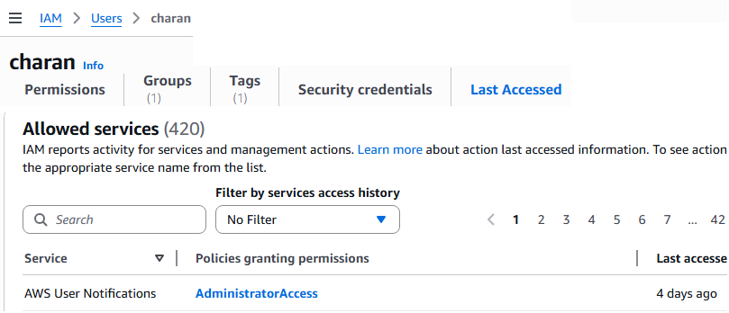 | here this last accessed tab will show all the AWS resources accessed by the user  it is like being admin, we can see all the activities of an iam user

IAM Best practices

Don’t use the root account except for AWS account setup , so create iam users and login as iam user instead of root user  • One physical user = One AWS user  • Assign users to groups and assign permissions to groups  • Create a strong password policy  • Use and enforce the use of Multi Factor Authentication (MFA)  • Create and use Roles for giving permissions to AWS services  • Use Access Keys for Programmatic Access (CLI / SDK)  • Audit permissions of your account using IAM Credentials Report & IAM  Access Advisor | Users: mapped to a physical user, has a password for AWS Console  • Groups: should contains users only  • Policies: JSON document that outlines permissions for users or groups  • Roles: will be given for EC2 instances or AWS services  • Security: MFA + Password Policy  • AWS CLI: manage your AWS services using the command-line  • AWS SDK: manage your AWS services using a programming language  • Access Keys: access AWS using the CLI or SDK using access keys  • Audit: IAM Credential Reports & IAM Access Advisor

Billing info
Note:- for public ipv4 address, aws will charge us
See the cost explorer to understand for which service I got billed
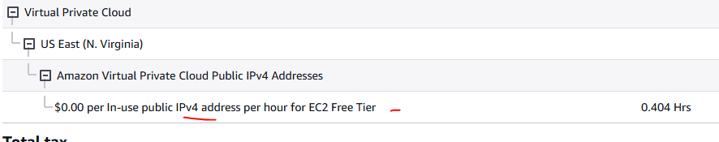 | , EC2 machine is free but for that machine public ipv4 address is billed only (not free)

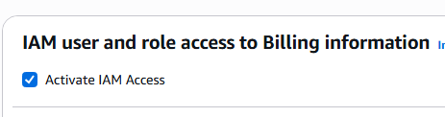 | if u want iam users to see the billing info  then goto root user Account and activate this check box  after that iam users also can see the billing info
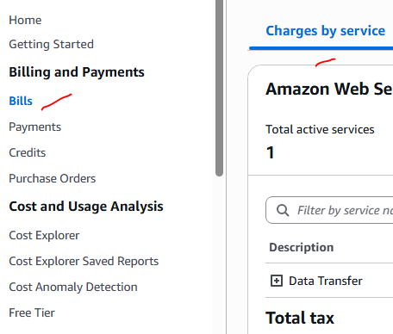 | to see d bills  goto bills charges by service    choose acc to billing perios    click on this free tier also to see if u are exceeding any free tier limits
to see for what service u got billed | here we can see why its billed

create a zero spend budget  so that if u cross that amount u will get mail | path  Budgets create 2 budgets  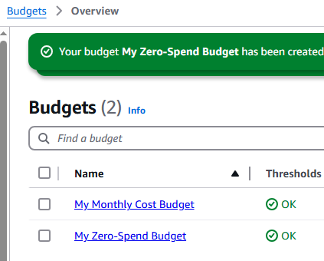  here I have created 2 budgets – if I cross my budget I will get mail

Install AWS CLI on windows
Instead on using AWS CLI on ur machines, its always best to use AWS cloud shell
https://docs.aws.amazon.com/cli/latest/userguide/getting-started-install.html
install using installer,
and create access keys using below path 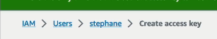 save those access key and value pairs locally

login in local win | before login 1st we have to get the access key user name and password 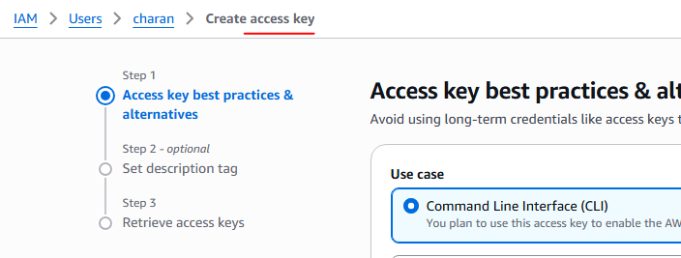 then configure /login to the console 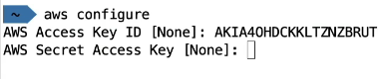 check the conn with below sample command “aws iam list-users” 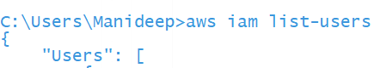
Accessing cloud shell (Browser based CLI) | just we have to click this button on aws to see cli in chrome itself  a user can get access to cloud shell when he has a “AdministratorAccess” policy  this policy can either be applied on a group and put him into this group, or we can attach directly on that person  note:- if user has only “IAMReadOnlyAccess” policy then he cant access cloud shell  cloud shell is not available in all regions (its only in few regions)  https://docs.aws.amazon.com/cloudshell/latest/userguide/supported-aws-regions.html  you can even download files from cloudshell using “Actions” tab

All aws services
s3(non- databases –) – like google drive which can store even movies  Databases –RDS (SQL), dynamo db (No-SQL to store key-value pairs), document DB (this is mongo db to store json data ), Redshift (Data warehouse), Aurora  athena – to query the csv,json,log files data present in s3 use this service  in sumologic or splunk, data will be stored in log file, we can directly write the queries and get count errors from log files…  Let’s say your app logs are stored in S3:👉 You want: Count errors then use athena service  Quicksight - is a cloud-based Business Intelligence (BI) tool used to analyze data and create interactive dashboards & visualizations this will create dashboards using data present in s3,RDS | Redshift – Dataware house (OLAP ) use SQL to query from data ware house  Timestream – to store time wise data like gps data , stock market data  Neptune –graph database to store the relationship for social media  ,Block chain,  Glue – to perform ETL Operations  DMS- database migration service –to migrate data from 1 to other database
Cache- ElastiCache – apps will use this cache and store data in cache , so instead of hitting db every time , get data from db | ECR- elastic container reg to store the docker images
Ec2 – this is a linux machine, lambda

AWS commands
aws –-version
aws iam list-users

EC2 instances
Note while creating Ec2 instances create them in ur region
  - If EC2 want to communicate with any other AWS services like dynamoDB- we will assign roles only to EC2 instances

EC2 means elastic compute cloud (elastic cloud computer ), computer they have re phrased as compute  with this we can take virtual machines for rent &  U can spin up aws EC2 linux machine instance within 2minutes – power of cloud (we can configure which o.s we want – windows/linux/redhat…)  And we can connect to that remote Ec2 linux computer from our local machine using SSH or using Browser | • It mainly consists in the capability of :  • Renting virtual machines (EC2)  • Storing data on virtual drives (EBS)  • Distributing load across machines (ELB)  • Scaling the services using an auto-scaling group (ASG)  Note:  every EC2 machine will have an ip addr, but in prod nobody will hit direct Ec2 instance, they will approach only to load balancer, ALB will re-direct traffic to Ec2 instances

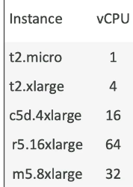Note while creating EC2 instance create that machine in ur region | 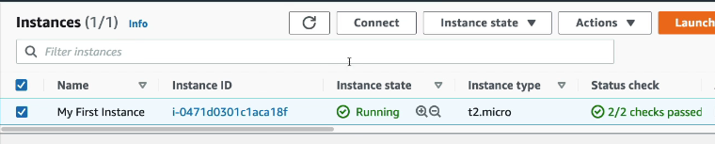  while creating a Ec2 machine, you can select the prop of machine, t2.micro, t2.xlarge  here t2.micro machine is free for us , we can use upto 750 free hours per month(full month is free)
Note if u want to connect to any EC2 instance using SSh /using Browser as below, 1st you should have the SSH inbound rule as below

What is SSH
SSH is Secure Shell. It's a network protocol used for securely connecting to remote computers or servers over a network. SSH is commonly used for tasks like remote login, file transfer, and executing commands on a server.
It allows you to control a remote machine, all using the command line.
Classic Ports to know  • 22 = SSH (Secure Shell) - log into a Linux instance  • 21 = FTP (File Transfer Protocol) – upload files into a file share  • 22 = SFTP (Secure File Transfer Protocol) – upload files using SSH  • 80 = HTTP – access unsecured websites  • 443 = HTTPS – access secured websites  • 3389 = RDP (Remote Desktop Protocol) – log into a Windows instance  Here inbound rules control the incoming traffic | 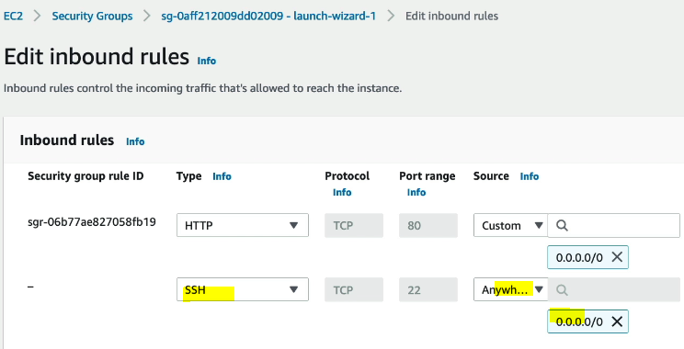  If SSH is missing, u cant connect to EC2 machine  so here SSH means always port 22  so here if HTTP is missing, ur app cant receive traffic

Traditional way is to connect using putty/windows 10 SSH
easiest way to connect to EC2 instance is using “EC2 Instance connect” using any browser
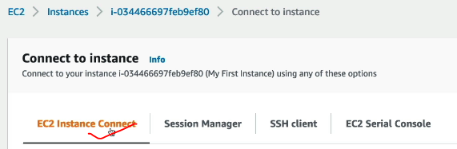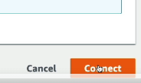

this is like browser based SSH instance
this is easy because we don’t need to manage SSH key at all,
once u click connect button from ur browser u can connect to EC2 instance
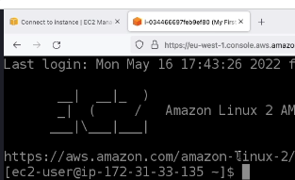

now if u type “aws iam list-users” it will fail, bec EC2 doesn’t have any role to list out the users  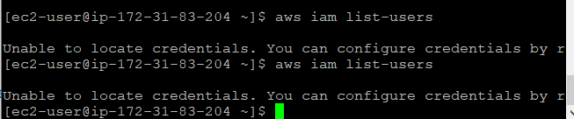  after attaching role – commands will give us data  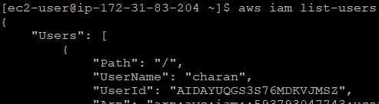 | 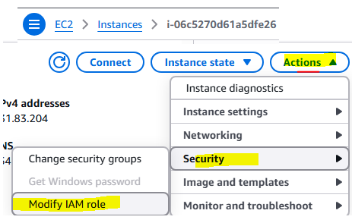  assign an iam role to an EC2 instance from this path

we can attach an IAM role to an EC2 instance  here for my EC2 instance, I am attaching a policy  - EC2 instances often need to interact with other AWS services, such as S3 (Simple Storage Service), DynamoDB, or RDS (Relational Database Service).  - Attaching an IAM policy grants the EC2 instance the necessary permissions to perform actions on those services  this is like making the EC2 instance as a developer/ putting that Ec2 instance in a developer group | 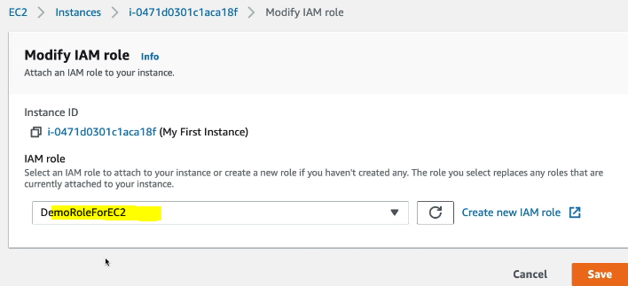  remve d ssh rule and see what issue will come- then u can never connect to ssh server

SSH connectivity issue
1) There's a connection timeout  This is a security group issue. Any timeout (not just for SSH) is related to security groups or a firewall. Ensure your security group looks like this and correctly assigned to your EC2 instance.  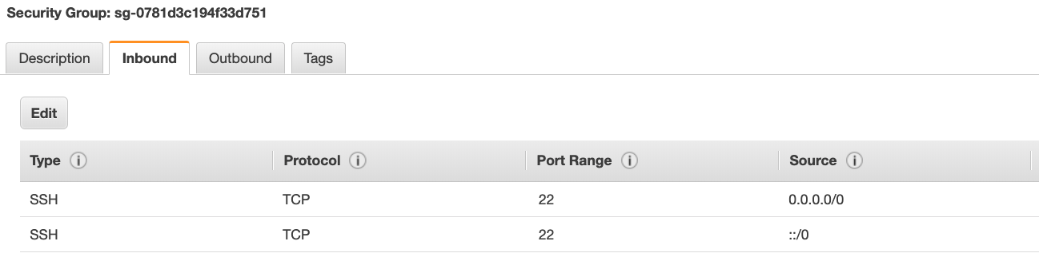  2) There's still a connection timeout issue  If your security group is properly configured as above, and you still have connection timeout issues, then that means a corporate firewall or a personal firewall is blocking the connection. Please use EC2 Instance Connect as described in the next lecture.  3) SSH does not work on Windows  - If it says: ssh command not found, that means you have to use Putty  - Follow again the video. If things don't work, please use EC2 Instance Connect as described in the next lecture | 4) There's a connection refused  This means the instance is reachable, but no SSH utility is running on the instance  - Try to restart the instance  - If it doesn't work, terminate the instance and create a new one. Make sure you're using Amazon Linux 2  5) Permission denied (publickey,gssapi-keyex,gssapi-with-mic)  This means either two things:  - You are using the wrong security key or not using a security key. Please look at your EC2 instance configuration to make sure you have assigned the correct key to it.  - You are using the wrong user. Make sure you have started an Amazon Linux 2 EC2 instance, and make sure you're using the user ec2-user. This is something you specify when doing ec2-user@<public-ip> (ex: ec2-user@35.180.242.162) in your SSH command or your Putty configuration  6) Nothing is working - "aaaahhhhhh"  Don't panic. Use EC2 Instance Connect from the next lecture. Make sure you started an Amazon Linux 2 and you will be able to follow along with the tutorial :)  7) I was able to connect yesterday, but today I can't  This is probably because you have stopped your EC2 instance and then started it again today. When you do so, the public IP of your EC2 instance will change. Therefore, in your command, or Putty configuration, please make sure to edit and save the new public IP.

Ex:- t2.micro = general purpose instance
Ec2 intance types- Many types of machines are there - https://aws.amazon.com/ec2/instance-types/
General purpose, compute optimised, memory optimised, storage optimised, accelerated computing
- We can configure a security group for our machine- ex:-
- inbound traffic rules(from which ip address Ec2 instance can accept traffic)
- and outbound traffic

EC2 imp points
- if u want to make ur app live, but for testing purpose, if ur don’t want to receive traffic then configure the security group by removing the http rule (,so that if ur app http port is closed/deleted ur cant receive HTTP traffic)
- Security Groups as Firewalls:
Security groups act as virtual firewalls, controlling inbound and outbound traffic to your EC2 instances.
- Blocking Inbound Traffic:
You can create or modify security group rules to block specific IP addresses, IP ranges, or even entire networks from accessing your EC2 instance.
- Example:
If you want to prevent access from a specific IP address, you would add a rule to the security group associated with your EC2 instance to block traffic from that IP.
  - We will keep iam users in group and
  - we will assign roles only to EC2 instances
stopping an instance | Terminating an instance
When you Stop an instance:  - The instance shuts down gracefully (like turning off your computer).  - The EBS root volume (your disk) is preserved.  - The instance ID remains the same (but public IP changes unless you use Elastic IP).  - You can start it again anytime.  🧠 Think of it like:  “Putting your EC2 machine in shutdown mode — you can restart it later and continue from where you left off.”  💾 Example use case:  - You’re learning or testing temporarily.  - You don’t want to pay for compute while not using the instance.  - You’ll resume work later.  💰 Billing impact:  - Compute (CPU, RAM): stops billing.  - EBS Storage: you still pay for the attached volumes.  So, while stopped:  You pay only for storage, not for compute. | What happens  When you Terminate an instance:  - The instance is permanently deleted.  - All data on the root volume (and other volumes if not set to “Keep”) is erased.  - You cannot restart it — it’s gone forever.  - The instance ID is lost.  🧠 Think of it like:  “Throwing away the computer — not just turning it off.”  💾 Example use case:  - You’re done testing and want to stop paying for it.  - You want to permanently remove a machine and its data.  💰 Billing impact:  - Compute: stops billing (immediately).  - Storage: stops billing after volumes are deleted.

best practice-
create 4-5 EC2 instances, add them to a group , App load balancer should refer this group to transfer the traffic ,
App load balancer should get traffic from internet
EC2 instances should get traffic only from ALB not from public , because due to Auto up & down scaling , in case of low load instance may be deleted and replaced again so ip address changes, hence
nobody should hit EC2 machine directly , they should hit load balancer url only

AMI overview
AMI = Amazon Machine Image
• AMI are a customization of an EC2 instance
• You add your own software, configuration, operating system, monitoring…
• Faster boot / configuration time because all your software is pre-packaged
• AMI are built for a specific region (and can be copied across regions)
•
and u can create image from existing Ec2 instance also  you can copy images from one to another machine | You can launch EC2 instances from any Image: same like docker image  • A Public AMI: AWS provided  • Your own AMI: you make and maintain them yourself  • An AWS Marketplace AMI: an AMI someone else made (and potentially sells)

Temp & Persistent storage types –

Persistent storage options - EFS, EBS, S3  Volatile storage - / RAM options ~~ Ec2 instance store  EbS = hard disk for Ec2 instance | If you only need to store files (not mount as disk) — use S3 instead.  It’s more durable, cheaper, and ideal for backups, images, logs, etc.

EBS (elastic block storage) volume
Type | Description
EBS (Elastic Block Store) -ROM | Network-attached, persistent disk — data survives stop/start
Instance Store (Ephemeral Storage) | Physically attached to the host machine — temporary storage

If u looking for high performance than EBS volume then use Ec2 instance store, this is little slow because this is a network drive
Ppt slide 96 – not for every Ec2 instance, an 8 GB EBS volume is defaultly attached (eventhough u shutdown instance, we will get billed for ec2’s EBS volume)
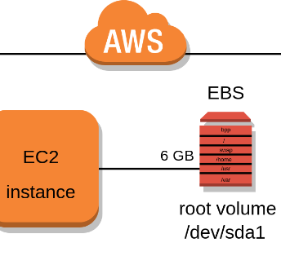  its like virtual hard drive | These EBS are like USB sticks or . It behaves like a persistent hard drive that you can attach to an EC2 instance. (at a time this USB stick/EBS can be attached only to 1 computer/1 EC2) after removing this EBS can be attached to another Ec2 instance  An EBS (Elastic Block Store) Volume is a network drive you can attach to your instances while they run ex;- to store some files  (network drive means a server/computer which is also attached to same network of ur EC2 , every one on the same network can access this server for storage and retrival purposes)  • It allows your instances to persist data, even after their termination  • 1 EBS can only be mounted to only 1 EC2 instance at a time (means 1 EBS cant be attached to multiple EC2 instances at a time)  • They are bound to a specific availability zone  • Analogy: Think of them as a “network USB stick”(means it is not like someone will go to datacenter and attach usb stick, its just online- It’s a network drive (i.e. not a physical drive )  • Free tier: 30 GB of free EBS storage of type General Purpose (SSD) or Magnetic per month  these EBS is attached to Ec2 using network  this can be

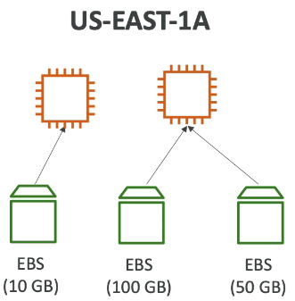  2 USB drive can be attached to 1 computer at a time, but 1 usb can not be attached to 2 computers at a time | 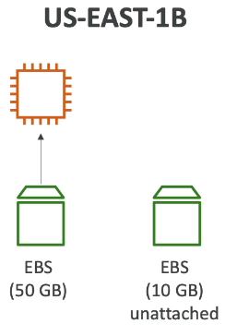  we can even leave them un attached, they can be atached on demand | It’s a network drive (i.e. not a physical drive)  • EBS gives you persistent storage that stays even if you stop or restart the instance.  An EBS Volume is a network drive you can attach to your 1 instance while they run, so your instances' data persist even after their termination.  use case• Your app needs to store files, logs, or data locally  • It uses the network to communicate the instance, which means there might be a bit of  latency  • It can be detached from an EC2 instance and attached to another one quickly (like USB stick)  • It’s locked to an Availability Zone (AZ)  • An EBS Volume in us-east-1a cannot be attached to us-east-1b  • To move a volume across, you first need to snapshot it  • Have a provisioned capacity (size in GBs, and IOPS)  • You get billed for all the provisioned capacity  • You can increase the capacity of the drive over time  by default when u create Ec2 instance then a EBS is auto attached to it , in my case an 8 GB EBS is defaultly given to ec2 instance  • network drives attached to one EC2 instance at a time • Mapped to an Availability Zones • Can use EBS Snapshots for backups / transferring EBS volumes across AZ

Don’t use EBS when:
- Your app doesn’t need persistent disk storage.
  - Example: Stateless Spring Boot microservices — use EFS or S3 for shared files or RDS for databases instead.
- You’re deploying on containers (ECS, EKS) or serverless (Lambda).
  - These prefer EFS or S3 for file persistence, not EBS.(bec 1 EBS cant be attached to multiple docker containers at a time, container is ephermal short lived)
- You need shared storage between multiple EC2s.
  - EBS volumes can be attached to only one instance at a time (except special multi-attach cases).
For shared access → use EFS (Elastic File System).

where can u see EBS attached to Ec2 | click on Ec2 instance storage // here it shows an 8 GB EBS volume is attached to our Ec2 instance  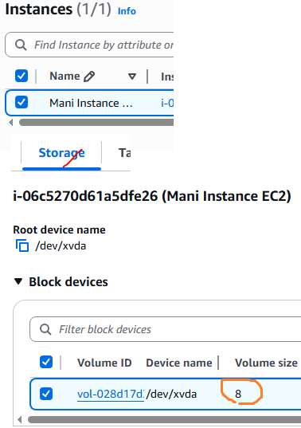 here when u click on volume u can see to which Ec2 instance it is attached Note- if u want to attach a volume to EC2 instance, then both EC2, volume must be in same region case 1- if ur Ec2 in north virginia region and if ur volume in europe then u cant attach that virgina volume to Europe Ec2 instance if u terminate the Ec2 instance, your default volume will be deleted automatically 💰 Billing impact: When u shutdown an EC2 instance- EBS volume will not be deleted- in this case we will get billed for EBS volume not for Ec2 instance when u terminate Ec2- then EBS volume will also get deleted since volume itself got deleted then no billing for EBS volume 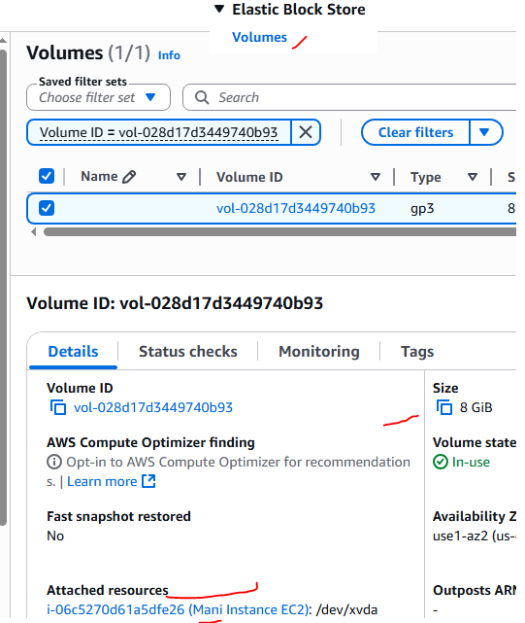

Ec2 instance store vs EBS
EC2 instance store == RAM for your EC2 (means data will be lost once instance restarted but its faster than EBS)
• EBS volumes are network drives with good but “limited” performance,
• If you need a high-performance hardware disk, use EC2 Instance Store, this is faster than EBS because this is directly attached to Ec2 instance
• Better I/O performance
• EC2 Instance Store lose their storage if they’re stopped (ephemeral means temporary), so for long term storage use EBS
• Good for buffer / cache / scratch data / temporary content
• Risk of data loss if hardware fails
• Backups and Replication are your responsibility

Why does Instance Store lose data?  Let’s break it down:  1️⃣ Instance store is tied to the physical hardware  - Each EC2 instance runs on a physical host.  - Instance store volumes are local SSDs or NVMe drives on that host.  - When you stop or terminate the instance, AWS may move it to another host later.  - Since the data lives only on the original host’s disks → it doesn’t persist.  So when the underlying host goes away, your instance store data goes with it.  Example  If you launch an instance with:  - 1 × 30 GB instance store – like u are starting an instance with 30GB RAM  - 1 × 20 GB EBS root volume- like 20 GB hard disk  Then:  - Files saved in /mnt (instance store) → ❌ lost on stop or terminate.  - Files in / (root EBS) → ✅ persist after stop/start.  When to choose this ?  like when u deploy a java app , since u need RAM memory (because all heap data stores here ) then we must create a EC2 machine with 10GB RAM – so create EC2 instance with 10GB Ec2 instance store  so when u are creating an Ec2 instance if u want some RAM then choose Ec2 instance store  for persistent storage – choose either EBS or EFS or S3 buckets | - Instance store = Laptop’s RAM (fast but temporary)  - EBS = Hard drive (slower but permanent)  Your EC2 instance loses data from instance store on stop or terminate because that storage physically exists only on that host’s hardware, which is released when you stop the instance.  AWS designed instance store for temporary, high-speed storage, not for permanent storage.  Think of it like:  “RAM for disk” — super fast, but volatile.  It’s meant for:  - Caching  - Temporary files  - Scratch space  - Buffering or intermediate data  Not for storing databases or application files permanently.  Scenario Recommended Storage  Need data to persist after stop/start EBS volume  Need data only while instance is running Instance store  Need to store images, logs, or backups S3 bucket

EFS vs EBS – elastic file systems

1EBS can be attached only to 1 Ec2 at a time,  but 1 EFS can be attached multiple Ec2 instances at a time  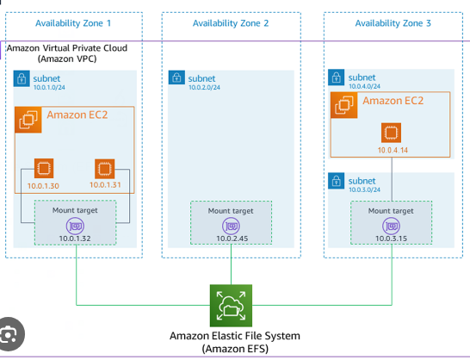  To create a shared network file system for your EC2 Instances – use EFS | • EFS works with Linux EC2 instances in multi-AZ  • Highly available, scalable, expensive (3x gp2), pay per use, no capacity planning  EFS is little cheaper as it has EFS infrequent access  EFS Infrequent Access (EFS-IA)  • Storage class that is cost-optimized for files not  accessed every day  • Up to 92% lower cost compared to EFS Standard  • EFS will automatically move your files to EFS-IA  based on the last time they were accessed  • Enable EFS-IA with a Lifecycle Policy  • Example: move files that are not accessed for 60  days to EFS-IA  • Transparent to the applications accessing EFS
Feature EBS (Elastic Block Store) EFS (Elastic File System)  Type Block storage (like a hard disk) Shared file storage (like a network drive)  Attached to One EC2 instance (single VM) Multiple EC2s simultaneously  Persistence ✅ Persists after stop/start ✅ Persists and shared  Performance Very high (low latency) Moderate (network-based)  Scalability Fixed size (must resize manually) Auto scales with data  Protocol Block-level (ext4, NTFS) NFS (Network File System)  Use case Single-server apps, databases Shared web apps, container clusters  Cost Cheaper per GB More expensive per GB  Region/AZ Scope Single Availability Zone Multi-AZ (high availability) | use case when to use which  One EC2 only, needs disk-like performance EBS  Multiple EC2s need shared access EFS  Database storage EBS  Shared web app or cluster EFS  Persistent user uploads across servers EFS  Cheapest option for persistence EBS
When to Use EBS  Choose EBS when:  - Your storage is used by only one EC2 instance.  - You need high IOPS (read/write performance).  - You’re running:  - Databases (MySQL, PostgreSQL, MongoDB)  - Application servers  - Single-instance workloads  - You want to take snapshots (for backup/restore).  🧠 Think of EBS like your EC2’s hard disk (C drive or root volume) — attached to one computer.  📘 Example:  Spring Boot app running on one EC2 → store logs, config, DB files on EBS. | When to Use EFS  Choose EFS when:  - You need shared storage accessible from multiple EC2 instances at once.  - You’re running multiple servers in parallel, like:  - Web servers behind a load balancer  - Containerized workloads (ECS, EKS)  - Shared application data directories  - You want auto-scaling — storage grows and shrinks as needed.  🧠 Think of EFS like a shared network drive accessible from many computers.  📘 Example:  A PHP or Node.js web app hosted on 3 EC2s — all share uploaded images or logs stored on EFS.  But:  - If you delete an EBS volume → data gone.  - If you unmount an EFS → data remains safe (until deleted manually).

ELB -Elastic load balancing – auto scaling groups
Elasticity means- scaling horizontally like adding one more server
Vertical Scalability | Horizontal Scalability
Vertical Scalability means increasing the size of the instance like increase RAM, ROM  • For example, your application runs on a t2.micro  • Scaling that application vertically means running it on a t2.large  • Vertical scalability is very common for non distributed systems, such as a database.  • There’s usually a limit to how much you can vertically scale (hardware limit)  Vertical Scaling: Increase instance size (= scale up / down)  • From: t2.nano - 0.5G of RAM, 1 vCPU  • To: u-12tb1.metal – 12.3 TB of RAM, 448 vCPUs | • Horizontal Scalability means increasing the number of instances / systems for your application • Horizontal scaling implies distributed systems.  • This is very common for web applications / modern applications  • It’s easy to horizontally scale thanks the cloud offerings such as Amazon EC2  Auto Scaling Group • Load Balancer
• High Availability: Run instances for the same application across multi AZ • Auto Scaling Group multi AZ • Load Balancer multi AZ  ex:- 1 Ec2 instance in north virginia, another Ec2 instance in mumbai  means we should keep instances in diff locations/ availibility zones | Flow  - User sends request  - ELB receives request  - ELB sends to EC2 instances

In real time, we will keep all EC2 instances in a group, so that ELB will will transfer the load to that group

Load balancers are servers that forward internet traffic to multiple servers (EC2 Instances) downstream.

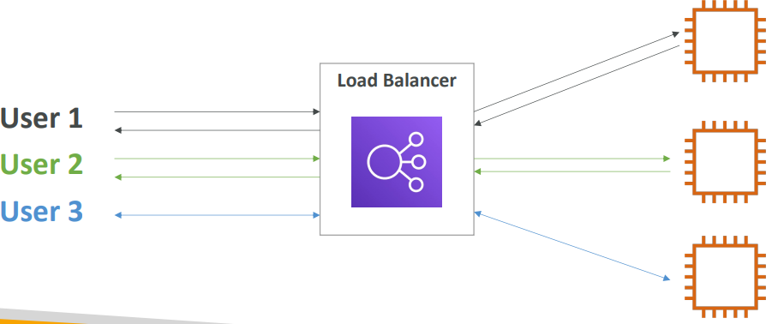 | 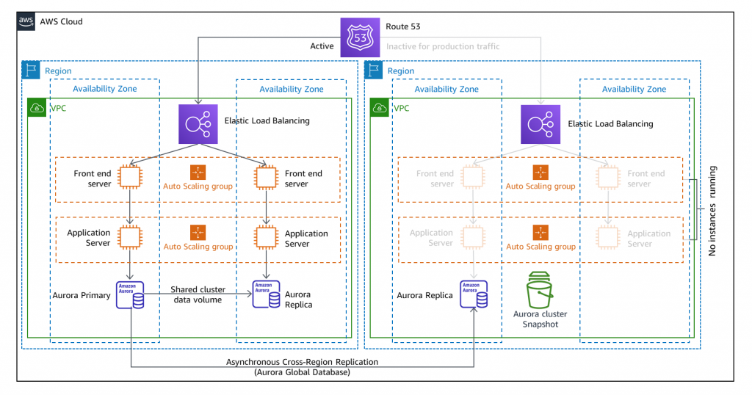

An ELB acts like a traffic police.  👉 It receives incoming user requests, B  👉 Then distributes them across multiple servers (EC2 instances)  note even in prod also we will hit direct load balancer url only, not direct EC2 instance, bec during load balancing when traffic is low instance can be terminated , so always hit ELB only not instances  📌 Why we need ELB?  Without ELB:  - All users hit one server  - Server crashes under heavy load 😵  With ELB:  - Traffic is distributed evenly to all EC2 instances  - Application becomes highly available  🔧 Types of ELB (Important for interviews)  - Application Load Balancer (ALB)  - Works at Layer 7 (HTTP/HTTPS)  - Smart routing (based on URL, path, headers)  - Example: /login → server1, /payment → server2  - Network Load Balancer (NLB)  - Works at Layer 4 (TCP/UDP)  - Ultra fast, low latency  - Classic Load Balancer (CLB) (old)  - Basic load balancing (not recommended now)  - Gateway load balancer  ⚙️ Key features:  - Health checks (removes unhealthy servers automatically)  - SSL termination  - Sticky sessions (optional)  - High availability across AZs | ✅ Simple idea:  ASG is like an automatic machine that adds/removes servers based on traffic  📌 What it does:  - When traffic ↑ → adds more EC2 instances (new instances will be auto registerd to ELB)  - When traffic ↓ → removes extra instances (ASG will replaced failed instances)  in E2 if u want to delete all instances, don’t delete each Ec2 instance, bec it will re-create, to delete all instances, delete this ASG or make count to zero  🎯 Example:  - Normal time → 2 servers  - Peak time → 10 servers  - Night time → back to 2 servers  👉 Saves cost + maintains performance  ⚙️ Key concepts:  - Min size → minimum servers always running  - Max size → limit to avoid overspending  - Desired capacity → current target number  🔥 Scaling types:  - Dynamic scaling  - Based on CPU, memory, etc.  - Example: CPU > 70% → add instance  if CPU < 30% → remove instance  - Scheduled scaling  - Example: Every day 9 AM → scale up  - Predictive scaling  - AWS uses machine learning to predicts traffic patterns  - Manual scaling -

Flow:  - User sends request  - ELB receives request  - ELB sends to EC2 instances  - ASG ensures:  - Enough instances are running  - Failed instances are replaced automatically  🧠 Real-world analogy:  - ELB = Receptionist distributing calls  - ASG = HR hiring/firing employees based on workload | ELB  - Distributes incoming traffic  - Improves availability & fault tolerance  👉 ASG  - Automatically adjusts number of servers  - Improves scalability & cost efficiency  👉 Together  - Build highly available + scalable systems

i have only 1 micro service and i want 10 instances of it, now which load balancer is needed , i dont want any path based routing as i have only 1 microservices-
Use Application Load Balancer (ALB)
Even though you don’t need path-based routing, ALB is still the best default for HTTP apps like Spring Boot.
what is path based routing & what is host based routing Simple meaning:  Routing based on URL path  👉 Example:  /employees → Service A  /orders → Service B  🔧 In your case (2 endpoints):  You said:  - /getEmployees  - /createEmployees  👉 These are just endpoints inside SAME app  So:  ❌ You DON’T need path-based routing yet | When path-based routing is useful?  When you split apps like:  Path Service  /employees Employee service  /payments Payment service  /orders Order service  User hits → /employees → Employee service (EC2-1)  User hits → /payments → Payment service (EC2-2)

Types of load balancer
What app load balancer does:  - Works at Layer 7 (Application layer)  - Understands HTTP/HTTPS requests , to load balance http/https traffic use app load balancer  🔧 Key capabilities:  - Path-based routing → /orders, /users (based on path it can re-direct to any Ec2 instance)  - Host-based routing → api.app.com (based on host name it can re-direct to any Ec2 instance)  - Supports microservices  - Can inspect headers, cookies, query params  - Built-in authentication (OIDC, Cognito)  - We can use this load bal even though we don’t want path or host based routing  🎯 Best for:  - Web apps (Spring Boot, REST APIs)  - Microservices architecture  - Content-based routing  behviour of ELB  when we attach a EC2 group to ELB, when any instance is down ELB will not send the traffic to that machine, ELB will continously check the health of each EC2, if health is good then only it will send traffic to healthy Ec2 machine | What does Network load balancer do :  - Works at Layer 4 (Transport layer)  - Handles TCP, UDP, TLS traffic  - Very high performance load balancer  It deals with:  - Ports (like 8080, 443)  - Connection (TCP handshake)  - Data delivery reliability  🔧 In your Spring Boot app:  When your app runs:  http://your-app:8080/getEmployees  👉 What happens:  - Request comes to port 8080  - TCP connection is established  - Data is sent to your app  👉 This is Layer 4 working, Which AWS offered Load Balancer should you use to handle hundreds of thousands of connections with low latency? – this network load balancer  🎯 Why Layer 4 is useful for you?  If you use Network Load Balancer (NLB):  - It doesn’t care about /getEmployees  - It only sees:  - IP address  - Port (8080)  👉 It just says:  "Send traffic to one of the servers running on port 8080"

Security groups for a load balancer
We need security groups even for a load balancer not just to EC2 machine to receive traffic
A Security Group (SG) is like a firewall that controls:  Who can access  On which port  Using which protocol  ex:- in security group we will define inbound and outbound rules on which port we should receive traffic and all  👉 It works at the resource level, not just EC2. | Security Group on Load Balancer  Controls:  👉 Who can access your application LB  Example:  - Allow:  - Port 80 (HTTP)  - Port 443 (HTTPS)  - Source: 0.0.0.0/0 (public users)  - Block:  - All other ports  👉 So only valid traffic reaches LB | Security Group on EC2  Controls:  👉 Who can access your EC2 instances  Best practice:  - Allow traffic ONLY from Load Balancer SG  - Not from public internet  Important Best Practice (VERY IMPORTANT)  ✅ Correct setup:  User → ALB ( ALB SG allows internet)  ALB → EC2 (EC2 SG allows only ALB)  Wrong setup:  User → EC2 directly (public access) ,  👉 This is security risk, user should come only via load balancer , he should not come to ec2 instance directly, because that instance can be down during up or down during auto scaling

ASG- auto scaling group
we will keep EC2 instances in a group, so that in that group if 1 instance is down, a new instance will be created automatically in that group  what is the use of sec group even for ASG  Security Group is NOT attached to ASG directly  Instead:  - It is attached to the EC2 instances inside the ASG  - You define it in the Launch Template / Launch Configuration  Flow:  - You create Launch Template  - Define AMI, instance type, Security Group  - ASG uses this template  - Whenever ASG creates instances:  - It automatically attaches that SG to that EC2 instance ,  👉 So every new instance is secured by default  What happens if you don’t use SG properly?  - EC2 instances may become:  - Publicly accessible  - Vulnerable to attacks  - Scaling creates more insecure instances  👉 Big production risk | 1. Consistent Security  Without SG in ASG:  - New instances may be open to internet  - Or wrongly configured 😵  With SG:  - Every instance follows same rules  ✅ 2. Works with Load Balancer  Best practice setup:  User → ALB → ASG (EC2 instances)  Configuration:  - ALB SG  - Allow: Internet (80/443)  - EC2 SG (via ASG)  - Allow: Only from ALB SG  👉 This ensures:  - No direct public access to EC2  - Only LB can talk to instances  4. Limits attack surface  Example:  - Allow only port 8080 from ALB  - Block everything else  👉 Even if hacker knows EC2 IP → cannot acces

S3 bucket (google drive)
S3 =simple storage service in s3 buckets( buckets== directories or folders) we will store files
Here we can store unlimited amount of data (.)
The Storage Gateway acts as a bridge between your on-premises environment and AWS, enabling hybrid cloud storage. When backups are created, they are securely uploaded to Amazon S3, which provides durable, scalable, and cost-efficient storage. This ensures that your backups are highly available and protected across multiple availability zones, while also allowing easy integration with other AWS services for further processing or archiving.

AWS S3 (Simple Storage Service) and Glacier are ideal storage solutions for backups

s3 use cases
Backup and storage • Disaster Recovery • Archive • Hybrid Cloud storage • Application hosting • Media hosting • Data lakes & big data analytics • Software delivery • Static website | Backups taken by AWS Storage Gateway are persistently stored in Amazon S3.  S3 provides durable, scalable, and cost-effective storage for frequently accessed backups,  while Glacier is designed for long-term archival storage at a lower cost for infrequently accessed data. Both services offer high durability, secure data storage, and integration with other AWS services, making them reliable options for backing up and protecting critical data.  Many AWS services also use s3 as an integration  What is diff between S3 and EBS in EC2
this s3 is same like a google drive here also we can store the files, images, pdf, docs ..  use cases  s3 can host static websites and have them accessible on internet | Amazon S3 allows people to store objects (files) in “buckets” (directories or folders) – same like kafka  • Buckets must have a globally unique name (across all regions all accounts)  • Buckets are defined at the region level  • S3 looks like a global service but buckets are created in a region  • Naming convention  • No uppercase, No underscore  • 3-63 characters long  • Not an IP  • Must start with lowercase letter or number  • Must NOT start with the prefix xn--  • Must NOT end with the suffix -s3alias

RDS vs S3 — Core Difference
Feature | Amazon RDS | Amazon S3 (like google drive)
Type of storage | Relational database (structured, tables, rows, SQL) | Object storage (unstructured data like files, images, videos)
Best for | Apps needing transactions, queries, relationships, or real-time data | Storing large files or static content like backups, media, logs
Access method | SQL queries (e.g., via JDBC, ORM, etc.) | REST API or AWS SDK (no SQL)
Example data | Customer records, product catalog, orders | Images, PDFs, logs, backups, videos
Scalability | Vertical + limited horizontal scaling | Virtually infinite scalability
Data format | Structured data | Any file (binary/text)
Consistency | ACID transactions (atomic, consistent, isolated, durable) | Eventual consistency for performance
Cost | Pay for compute (instance hours) + storage | Pay only for storage used (per GB)
Performance | Low latency for transactions | Optimized for throughput and bulk data transfer

When to use RDS
Use Amazon RDS when you need:
- A database with relationships between tables (e.g., Customers → Orders → Payments).
- To query data with SQL (SELECT, JOIN, WHERE, etc.).
- Real-time data updates.
- Transactional consistency (banking, inventory systems, etc.).
- Example use cases:
  - Web applications (Java, Spring Boot, Django, etc.)
  - E-commerce product & order databases
  - Financial or billing systems
  - Employee management systems

💾 When to use S3

Use Amazon S3 when you need:  - To store files, images, videos, backups, or logs.  - Static website hosting.(since it is like google drive , put all html files to that drive, access html files using bucket url or each object will also have some global url )  - Data lakes or analytics inputs.  - Backups of RDS or EC2.  - Example use cases:  - Store user-uploaded files or images  - Application logs or analytics data  - Backup your database or EC2 snapshots  - Host static HTML/CSS/JS websites  - Store ML training datasets  - All the movies in netflix are stored in s3 buckets | Scenario Use  Need SQL, relationships, transactions RDS  Need to store images, files, backups S3  Store analytics logs or ML data S3  Real-time web app database RDS  Backup RDS snapshots S3  Serve static website content S3  How Netflix Uses AWS  ✔ What runs on AWS  Netflix moved most of its backend to AWS after a major outage in 2008.  They use AWS for:  - Compute → Running microservices (recommendations, user profiles)  - Storage → Movies/metadata in services like Amazon S3  - Databases → User data, viewing history  - Analytics & ML → Personalized recommendations  👉 Almost the entire control plane (brains of Netflix) runs on AWS.
note  you can store images or app logs , PDFs in RDS its Technically possible — but inefficient  INSERT INTO documents (id, name, data) VALUES (1, 'resume.pdf', <binary data>);  • Every file increases database size dramatically.  • Databases are optimized for queries, not for serving large binary files.  • Backups, restores, and replication become slow and expensive.  Let’s say you store 10 GB of images:  - In RDS → You pay for DB storage + instance hours (~₹1,000–₹2,000/month)  - In S3 → You pay only for storage (~₹20–₹30/month)  That’s a ~100× difference in cost for the same data!  misc info  - u can create the snapshot for the ebs volume, and u can even copy those snapshots to any location  - u can even store that snapshots in snapshot buckets (70% cost effective)  - after deleting those EBS volume snapshots and AMI (amazon machine image),  they will be moved to recycle bin and there it can stay 1-2 days dep on configuration  - re-creating the volume for snapshot :- u can even again create back the volumes from the selected snapshots created  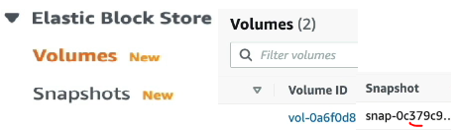  here this shows a volume which is created from the mentioned snapshot | So your Java app:  - Uploads the file to S3  - Stores the URL and metadata in RDS  This gives you the best of both worlds  In Amazon S3:  - Everything is stored as objects  - Each object has:  - Key (name) file name  - Value (file data)  📂 Then why do we see folders?  Because of key naming  Example:  employees/2026/march/report.pdf  👉 This is NOT a real folder structure  It is just one string (key):  "employees/2026/march/report.pdf"  🧠 Important concept: Prefix  - employees/ → prefix  - employees/2026/ → deeper prefix  👉 S3 console shows these as folders for human readability  🎯 Example to understand clearly  These 3 objects:  a.txt  employees/a.txt  employees/2026/a.txt  👉 In S3:  - All are stored at same level internally  - No real parent-child relationship

S3versioning Why S3 buckets names must be unique
Because Amazon S3 uses a global namespace and bucket names are part of the public URL. Since bucket name must be part of url, if 2 buckets have same name it cant redirect properly to a certain bucket , so bucket name must be unique across all regions  Example URL:  https://my-company-data.s3.amazonaws.com/file.txt  👉 Here:  - my-company-data = bucket name  🔥 Problem if not unique:  If two people create same bucket name:  my-company-data  👉 AWS won’t know:  - Which user’s bucket to route request to 😵 | Amazon S3 Versioning when u mistakenly overriden a file with same name then all versions will be preserved  this feature of Amazon Simple Storage Service (S3) that lets you keep multiple versions of an object (file) in the same bucket.  if file name is same, Instead of overwriting or permanently deleting a file, S3 stores every version of it, so you can recover older versions if needed.  🔹 Key Concepts  - Version ID  Every object gets a unique version ID when versioning is enabled.  - Multiple Versions  If you upload a file with the same name again, S3:  - Does NOT overwrite the old file  - Creates a new version alongside the old one (same like snapshot)

🔹 Example  - Upload file.txt → Version ID: v1  - Upload file.txt again → Version ID: v2  - Delete file.txt → Delete marker added  You can still retrieve:  - v1 (original)  - v2 (latest actual file before delete) | Benefits  - Data protection (accidental deletes or overwrites)  - Easy recovery / rollback  - Helps with compliance and auditing  - Works well with backup and lifecycle policies

how to delete and restore the deleted the object  when u delte an object then delete marker will be kept on that object, hence u cant access that file  when u delte that marker, then object will be restored then u can access that file | - Delete Marker  When you delete an object:  - S3 doesn’t remove it permanently  - It adds a delete marker, making it appear deleted  - Older versions still exist and can be restored

S3 Replication
Amazon S3 Replication is a feature that automatically copies your objects from one S3 bucket to another—either in the same region or a different region.

🔹 Simple Definition
S3 Replication = automatically keeping a duplicate copy of your data in another bucket for safety, backup, or performance.
Types of Replication  1. Same-Region Replication (SRR)  - Copies data within the same AWS region  - Useful for:  - Log aggregation  - Compliance requirements  2. Cross-Region Replication (CRR)  - Copies data to a different AWS region  - Useful for:  - Disaster recovery  - Lower latency for global users | How It Works  - You upload a file to Source Bucket  - S3 automatically copies it to Destination Bucket  - Replication happens asynchronously (in background)  🔹 Example  - Source bucket: india-bucket  - Destination bucket: us-backup-bucket  Upload photo.jpg →  S3 automatically creates a copy in destination bucket  Important Requirements  - ✅ Versioning must be enabled on both buckets  - ✅ Proper IAM permissions/role required  - ✅ You define a replication rule | Cost Consideration  Replication is not free:  - Charged for:  - Storage in destination bucket  - Data transfer between regions  - Replication requests  here, replication rule is responsible to replicate the data from source to dest bucket  so create replication rules which define how to replicate

S3 storage classes
Quick Comparison
Storage Class | Access Speed | Cost | Use Case
Standard | Milliseconds | High | Frequent access
Intelligent-Tiering | Auto | Medium | Unknown patterns
Standard-IA | Milliseconds | Lower | Rare access
One Zone-IA | Milliseconds | Cheapest IA | Non-critical
Glacier Instant | Milliseconds | Low | Archive + fast
Glacier Flexible | Minutes–Hours | Very Low | Backup
Deep Archive | Hours | Lowest | Long-term storage
Durability means whether it will store safely or not without any loss of file in s3 bucket, S3 will be down onlu 1 hour per year

S3 Standard  - For frequently accessed data  - High availability & low latency  - Use cases:  - Websites  - Apps  - Frequently used files  💰 Cost: Highest among S3 classes | S3 Intelligent-Tiering  - Automatically moves data between tiers based on usage  - No need to decide manually  Use cases:  - Unknown or changing access patterns  💰 Cost: Saves money automatically (small monitoring fee) | S3 Standard-IA (Infrequent Access)  - For rarely accessed but needed quickly  - Lower storage cost than Standard  - Retrieval cost applies  Use cases:  - Backups  - Disaster recovery | S3 One Zone-IA  - Stored in one availability zone only  - Cheaper than Standard-IA  - Less durable  Use cases:  - Non-critical backups  - Re-creatable data
S3 Glacier Instant Retrieval  - Archive data but still instant access  - Lower cost than IA  Use cases:  - Medical records  - Archived images  - Min storage 90 days | S3 Glacier Flexible Retrieval  - Very cheap storage  - Retrieval takes minutes to hours  Use cases:  - Backup archives  - Min storage 90 days | S3 Glacier Deep Archive  - Cheapest storage option  - Retrieval takes hours (up to 12 hrs)  Use cases:  - Long-term backups (years)  Min storage 180 days

do we need to choose storage class for each object, or the storage class is for 1 bucket  Storage class is applied at OBJECT level, not bucket level  You can store different objects in the same bucket using different storage classes.  🔹 How It Works  - A bucket is just a container  - Each object (file) inside the bucket can have its own:  - Storage class  - Metadata  - Permissions  🔹 Example  In one bucket:  - image.jpg → S3 Standard  - backup.zip → S3 Glacier  - logs.txt → S3 Standard-IA  👉 Same bucket, different storage classes | When Do You Choose Storage Class?  1. During Upload  You can specify storage class while uploading:  - AWS Console  - CLI  - SDK  If you don’t choose:  👉 Default = S3 Standard  so after uploading an object also u can change that object storage class from any to any like , standard to Infrequent access or …  bec from java or during upload if u miss to choose storage class, u can happily change the class after uploading  S3 storage class is defined at the object level, not at the bucket level. A single bucket can contain objects with multiple storage classes | After Upload (Lifecycle Rules)  You can automatically move objects:  - After 30 days → Standard → IA  - After 90 days → IA → Glacier  👉 This is called Lifecycle Policy

S3 express 1 zone
Amazon S3 Express One Zone is a , where data is stored in a single Availability Zone (AZ).
S3 Express One Zone = fastest S3 storage, stored in one AZ, optimized for high-performance workloads
10times faster than s3, but lower durability as data will be only in single availability zone
Key Features  ⚡ Ultra-low latency  - Much faster than normal S3  - Ideal for real-time applications  🚀 High throughput  - Handles thousands of requests per second  📍 Single Availability Zone  - Data is stored in only one AZ  - Not replicated across multiple AZs (unlike S3 Standard) | Use Cases  - Big data analytics  - AI / ML workloads  - Real-time processing  - High-performance computing (HPC)  Feature S3 Express One Zone  Speed 🔥 Very High  Cost Medium  Durability Lower (single AZ)  Availability Lower than Standar | Difference from Other Classes  Storage Class Zones Speed Use Case  S3 Standard Multi-AZ High General purpose  One Zone-IA Single AZ Medium Cheap storage  S3 Express One Zone Single AZ 🚀 Very High Performance-critical  Important Notes  - Uses directory buckets (different from normal buckets)  - Designed for short-lived, high-speed access like kafka  - Not ideal for:  - Backups  - Critical long-term storage  🔹 Simple Analogy  Think of it like:  - 🏎️ S3 Express One Zone → racing car (very fast, but less safe)  - 🚗 S3 Standard → normal car (balanced speed + safety)

S3 Encryption
Means , store only encrypted data , means when we send plain un-encrypted data aws will receive & encrypt data just before storing (so now data is encrypted during rest , )
Amazon S3 Encryption means protecting your data by converting it into an unreadable format so that only authorized users can access it.

🔹 Simple Definition
S3 Encryption = securing your files in S3 so even if someone accesses them, they can’t read the data without a key
👇

🔐 Server-Side Encryption Types in S3
All three are Server-Side Encryption (SSE), meaning:
Data is encrypted after it reaches S3 (inside AWS) so this is called data encryption at REST , there is another thing called data encryption at transfer

SSE-S3 (Simple & Default)  What it is  - AWS encrypts your data using S3-managed keys  - You don’t see or manage keys at all  🔑 Key Management  - Fully handled by AWS  👍 Advantages  - Very easy to use (just enable it)  - No extra cost  - Automatically enabled by default in S3  👎 Limitations  - No control over keys  - No detailed audit of who accessed encryption keys  📌 Use Case  - General applications  - When you don’t need strict security control | SSE-KMS  What it is  - Uses AWS Key Management Service  - AWS manages keys, but you control them  🔑 Key Management  - You can:  - Create keys  - Control access (IAM policies)  - Rotate keys  - Track usage  👍 Advantages  - Fine-grained access control  - Audit logs via CloudTrail  - Better security compliance  👎 Limitations  - Slightly higher cost (KMS API charges)  - Slight latency overhead  📌 Use Case  - Banking apps 💰  - Healthcare 🏥  - Any sensitive data system | 🔹 3. SSE-C (Customer-Provided Keys)  What it is  - You provide your own encryption key with every request  🔑 Key Management  - AWS does NOT store your key  - You must:  - Send key during upload  - Send same key during download  👍 Advantages  - Full control over keys  - AWS never sees your keys stored  👎 Limitations  - Very complex to manage  - If key is lost → data is lost permanently ❌  - Not commonly used in real-world projects  📌 Use Case  - Highly sensitive environments  - When company policy requires external key control

AWS physical SNOW ball devices
AWS Snow devices (Snow Family) are physical hardware devices provided by Amazon Web Services to transfer large amounts of data to/from AWS cloud—especially when internet bandwidth is slow, expensive, or unavailable.

❄️ AWS Snow Family Overview  👉 Think of it like this: instead of sending huge data over the internet, AWS sends you a device → you load data → ship it back → AWS uploads it to cloud.  ✔ Used for:  - Data migration (TB → PB → Exabyte scale)  - Edge computing (run apps near data source)  - Remote locations with poor network  charges  data transfer from ur data center to snow ball device is free, but when u transfer from aws to snow ball devices then its chargeable (as u are going out from aws) | 1. AWS Snowcone (Smallest)  • Small, portable (~2 kg)  • Storage: ~8 TB  • Can run lightweight compute (EC2 instances)  • Works even in harsh environments  👉 Best for:  - IoT devices  - Remote areas (factories, vehicles)  - Small data transfer  ✔ Example: collecting sensor data from a remote mining site | 2. AWS Snowball (Medium / Most Used)  - Large storage (50 TB – 80 TB+)  - Available in:  - Storage optimized  - Compute optimized (with GPU option)  - Can cluster multiple devices  👉 Best for:  - Data center migration  - Backup & disaster recovery  - Machine learning at edge  ✔ Handles TB → PB scale data  A non-profit organization needs to regularly transfer petabytes of data to the cloud and to have access to local computing capacity. Which service can help with this task?  use snowball edge | AWS Snowmobile (Largest 🚛)  • A 45-foot truck/container  • Transfers up to 100 PB per truck  • AWS brings it to your data center  Best for:  - Migrating entire data centers  - Huge datasets (video archives, genomic data)  ✔ Example: Netflix-scale data migration

Storage gateway
👉 AWS Storage Gateway is a hybrid cloud service that connects your on-premises applications to AWS cloud storage (mainly Amazon S3 and backups).
This gateway will sync the data from our data center to aws s3
Simple Idea  👉 “It acts like a bridge between your local data center and AWS cloud storage.”  - Your app thinks it’s writing to local storage  - Actually, data is stored in AWS  👉 Today:  - If your data center fails → data loss risk  👉 With Storage Gateway:  - Your app writes files normally  - Gateway automatically pushes our data center data to Amazon S3  ✅ Benefit:  - Instant cloud backup  - Easy disaster recovery | Handle Large Files Efficiently  If your app:  - Uploads documents  - Generates reports  - Stores logs  👉 Instead of filling local disk:  - Gateway stores data in S3  - Keeps only frequently used data locally  ✅ Benefit:  - Unlimited scalable storage  - No disk management headache  Most suitable: File Gateway  - Works like shared folder (NFS/SMB)  - Perfect for:  - Logs  - Uploads  - Reports | Real Example (Your App)  👉 Your Spring Boot app:  - User uploads file  - App processes it  - Saves output file  Without Gateway:  - Stored locally → risk + limited space  With Gateway:  - Stored in S3 automatically  - Cached locally for fast access  now if ur app stores files in nfs(not in db)  then this storage gateway will sync those files from nfs to s3

Athena overview
use this service when u want to query and analyse json,csv,log files in the s3  Amazon Athena is a serverless Managed SQL query service from Amazon Web Services.  here serverless means we don’t need to create server, aws will create internally and it will manage  👉 Simple idea:  You can run SQL queries directly on data stored in S3 without creating any database or server.  Data stored in S3  ↓  Athena runs SQL query  ↓  Results returned (no server needed) | 🧠 Why Athena is useful  Normally:  - Data in files (CSV, JSON, logs) → hard to analyze ❌  With Athena:  - Use SQL like:  SELECT * FROM logs WHERE status = 500;  👉 And get results instantly  Real time use case  in sumologic or splunk, data will be stored in log file, we can directly write the queries

Key features  1. Serverless  - No EC2, no cluster  - Just write query → run  2. Pay per query  - Charged based on data scanned  - No cost when idle  3. Supports standard SQL  - Easy for developers  4. Works with multiple formats  - CSV  - JSON  - Parquet (optimized) | 🧑‍💻 Example use case  Let’s say your app logs are stored in S3:  👉 You want:  - Count errors  - Analyze traffic  Query:  SELECT count(*) FROM logs WHERE status = 500;  👉 Athena reads files → gives result

Databases
RDS- relational database service, with aws RDS we can create databases in cloud like we can create postgres, mysql, maria, oracle, ms sql server, ibm db2, aurora (aws proprietary db)
With aurora also we can create 2 dbs- postgres, mysql , since aws is already providing RDS for mysql, postgres,
Aurora is properitery “AWS cloud optimized” and claims 5x performance improvement over MySQL on RDS, over 3x the performance of Postgres on RDS
Advantage over using RDS versus deploying DB on EC2 (like in local we will install db on our windows lap , lly why cant we install our db on any Ec2 ins tance)  • RDS is a managed service:  • Automated provisioning, OS patching  • Continuous backups and restore to specific timestamp (Point in Time Restore)!  • Monitoring dashboards  • Read replicas for improved read performance  • Multi AZ setup for DR (Disaster Recovery)  • Maintenance windows for upgrades  • Scaling capability (vertical and horizontal)  • Storage backed by EBS  • BUT you can’t SSH into your instances | 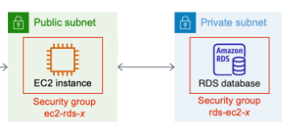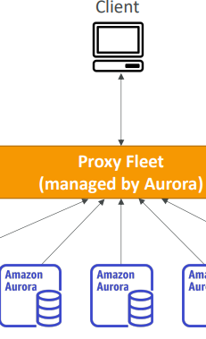  this aurora is bit more powerful as this can auto scale | total 3 ways of creating databases  - installing db manually on Ec2 instances [but we have to manage patching]  - using AWS RDS like RDS mysql, postgres RDS here In this case aws will take of patching upgrades.. everything  - using AWS aurora mysql

since DB2 is not provided by RDS  On AWS EC2 (Most Common Cloud Approach)  - Amazon EC2  ✔ Setup:  - Launch EC2 instance  - Install Db2 manually  - Use EBS for storage  ✔ High Availability:  - Multi-AZ using replication  - Failover scripts or clustering | 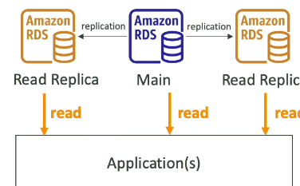 | RDS deployments – 3 types of RDS deploments  - Read replicas – for reading we will create many intances  - Multi AZ – means in same region multiple data centers – so in case of fail over writes will happen to another dc  RDS benefits  - With RDS u can scale upto 15 read replicas  - Writing data only to single db
RDS deployments
1️⃣ Single-AZ Deployment (single DC)  Database runs in one Availability Zone  ✔️ Features  - One DB instance  - No automatic failover  - Lowest cost  ❌ Problem  - If that AZ goes down → DB goes down  ✅ Use case  - Dev / Test  - Small applications | 2️⃣ Multi-AZ Deployment (High Availability) – same region multiple dc  means in same hyd region Database runs in 2 different Azs or 2 data centers  - Primary → used by app – read and write will be happenning only on 1 AZ when this failed, then auto switch over to next AZ  - Standby → synced copy  ✔️ Features  - Automatic failover  - Data replication (real-time)  - High availability  ❌ Problem  - More cost  ✅ Use case  - Production apps  - Banking / critical systems | 3️⃣ Read Replicas (Scaling) Multi-region – diff cities like mum,hyd  👉 Used to handle heavy read traffic  - One primary (writes) every one will write to this db  - Multiple replicas (reads) , here db will be in separate regions like 1 in hyd, 1 in banglore ,1 in iran, 1 in israel  ✔️ Features  - Improves performance  - Good for reporting / analytics  ❌ Problem  - Not automatic failover (manual promotion needed)  - Higher replication cost  ✅ Use case  - High-traffic apps

Snapshots
Once ur db is up , u can take a snapshot of it, snapshot == copy of database, once u restore the snapshot u will get a new database instance with all data from that snapshot on a new instance or url
When you restore an RDS snapshot What Exactly Gets Restored?:  ✅ Data  - All tables  - All records  ✅ Schema  - Tables, indexes, constraints  ✅ DB Engine & Version  - Same engine (MySQL, PostgreSQL, etc.) | What You DO NOT Get (Important)  ❌ It does NOT overwrite existing DB  - It creates a new DB instance  ❌ Some configurations may differ:  - Endpoint (new URL)  - Security groups (can be reconfigured)  - Parameter groups (can be changed)

ElasticCache overview
this cache is fast as this will be in RAM not ROM
Amazon ElastiCache is a managed in-memory cache service (uses engines like Redis and Memcached) to store temporary data.
👉 Simple idea:It stores frequently used data in RAM so your app doesn’t hit the database every time.+

You don’t configure ElastiCache “for EC2 or DB” directly
Instead: Your application (running on EC2 or anywhere) uses ElastiCache to cache data from any database (“ElastiCache is an application-level caching layer, not a database-attached feature.”)

User → Your App (EC2 / Spring Boot)  ↓  Check Cache (ElastiCache)  ↓  If not found → DB (RDS/DynamoDB/Document DB/etc.)  ↓  Store result in Cache | 🏗️ So what can it be used with?  ✅ 1. With EC2 (or any app server)  - Your app runs on Amazon EC2  - App connects to ElastiCache  - App decides what to cache  👉 This is the main usage | ✅ 2. With ANY database  You can cache data from:  - Amazon RDS  - Amazon DynamoDB  - MongoDB / DocumentDB  - Even external APIs  👉 ElastiCache is database-independent | Important point  ElastiCache:  - ❌ Does NOT directly connect to DB automatically  - ❌ Does NOT replace DB  👉 Your application controls caching  Common caching patterns  1. Cache-aside (most used)  - App checks cache first  - If missing → fetch from DB → update cache  2. Write-through  - Write to cache + DB together

Dynamo db (No-SQL) like mongo db
📦 What is DynamoDB? If u want to store data in key-value pairs prefer this
Amazon DynamoDB is a fully managed NoSQL database provided by Amazon Web Services. Note this is only good for read,write operations & never user this for aggregate operations and analystics
👉 In simple terms:
It’s a high-speed, scalable database designed to handle millions of requests per second without you managing servers [this much fast is because of data partitioning before storing].
Millions of requests per seconds, trillions of row, 100s of TB of storage

How DynamoDB is different (core idea)  Unlike traditional databases (like MySQL, Oracle):  - ❌ No tables with complex joins  - ❌ No fixed schema  - ✅ Flexible structure  - ✅ Extremely fast reads/writes  - ✅ Auto scaling  DynamoDB → Native AWS NoSQL  DocumentDB → MongoDB-like  this is a distributed server less database Even though Amazon DynamoDB is called serverless…  👉 Servers DO exist — but AWS manages them for you.  - so in dynamo db we don’t create any db we will directly create tables  why they named as dynamo db  Real Dynamo:  - Power distributed to many places  DynamoDB:  - Data distributed across many servers/partitions | Basic building blocks  1. Table  - Similar to a table in relational DB  - Stores your data  2. Item  - A single record (like a row)  3. Attributes  - Columns (but flexible — each item can have different attributes)  Your Spring Boot app  ↓  DynamoDB API (AWS endpoint)  ↓  AWS internal servers (hidden)  ↓  Data stored/retrieved  ↓  Response back to you | 🔑 Primary Key (very important concept)  Every table must have a primary key:  dynamo db stores data across multiple partitions  this is a key value databasen  Option 1: Partition Key  - Example: userId  - Data is distributed across servers based on this  Option 2: Composite Key  - Partition key + Sort key  - Example:  - userId (partition key)  - orderDate (sort key)  👉 This helps in fast querying and sorting  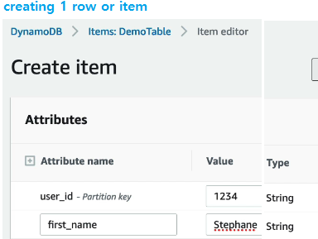

⚡ Why DynamoDB is so fast  - Data is stored in multiple separate partitions because of partition key Data is split across many machines (means partitioned data is stored physically in seperate locations, like 5 states aadhar info in 1 partition, another state data In another partition )  - Requests are distributed across servers  - Uses SSD storage internally  - No joins → direct access | Scaling (big advantage)  - Automatically handles traffic spikes  - No need to increase servers manually  - Handles thousands to millions of users easily  - Fully Managed in-memory cache for DynamoDB named dynamo db accelerator • 10x performance improvement this is the exclusive cache for dynamo db  - Use this for fast data retrival  DynamoDB → Like a pre-organized warehouse (everything indexed in advance) | When to use DynamoDB  ✅ Best for:  - High traffic apps (e.g., e-commerce, gaming)  - Real-time systems  - Microservices architecture  ❌ Not ideal for:  - Complex joins – this dynamodb wont allow joins at all  - Heavy relational queries  - Strong transactional systems (like banking)

what is the use of partition key  partition == physically separate db  here theme is splitting and storing the data in diff physical servers  ex:- all USA , india data in separate partitions  we will calculate the hash value of partition key col (like country col) based on hash value the item we will store the item or row in diff partition –this is same like storing data in hash map  partition key = a column which is used to derive the partition num  DynamoDB stores data across multiple servers (partitions)  It uses the partition key to decide:  👉 “Which server should store this it em?”  ✔ It applies a hash function on the partition key  ✔ This spreads data evenly across servers | 2. ⚡ Fast data retrieval  When you query:  GetItem(userId = 101)  👉 DynamoDB:  Uses partition key  Directly goes to correct partition  Fetches data instantly  ✔ No scanning needed  ✔ Very fast (milliseconds)  ⚠️ Important limitation  👉since partitioned data is stored in separate machines You can ONLY efficiently group/query:  Data with same partition key  ❌ You cannot easily:  Join across partitions  Query unrelated partition keys | 3. 📈 Enables massive scalability  Because of partition key:  - Data is split across many machines  - Traffic is distributed  - No single server overload  👉 That’s how it handles millions of requests  ex:- if partition col is country if value is USA or india, it will calculate the hash and decide the partition num, req will be routed to that partition in that partition data will be stored  Partition key is used for both storage + retrieval

Global table
 | Global table means it is present in multiple regions .  Amazon DynamoDB Global Tables allow you to have the same table replicated across multiple AWS regions automatically.  Data written in one region  Automatically copied to other regions  Write in Mumbai → replicated to Virginia → replicated to London  🛡️ High availability (disaster recovery)  - If one region fails  👉 Your app continues using another region | how to identify if it is a normal or global table  👉 “Do I see this same table in multiple regions?”  Example:  ap-south-1 (Mumbai) → table exists  us-east-1 (Virginia) → same table exists  ✔ Then it’s a Global Table  ❌ Only in one region → normal table

How it works internally  Uses active-active replication  Every region:  Can read ✅  Can write ✅  👉 No “primary” region, hence we can write to any region and we can read from any region  🧑‍💻 When to use Global Tables  ✅ Use cases:  - Global applications (e-commerce, gaming, SaaS)  - Multi-region users  - Disaster recovery requirement  ❌ Avoid if:  - App is local (India-only users)  - Cost-sensitive project | User updates profile in India  ↓  Data written to Mumbai region  ↓  Auto replicated to US & Europe  means any write operation in 1 region will be synced to remaining regions, there is no main region like master-slave all are equal  ⚠️ Conflict handling (important)  What if:  - Same item updated in 2 regions at same time?  👉 DynamoDB uses:  Last writer wins (based on timestamp) | Requirements  To use Global Tables:  Same table schema in all regions  Same primary key structure  Enable streams internally  💰 Cost consideration  You pay for:  Writes in each region  Replication traffic  Storage in multiple regions  👉 Cost increases with regions

Quick sight

👉 Amazon QuickSight is a cloud-based Business Intelligence (BI) tool used to analyze data and create interactive dashboards & visualizations.  🧠 Simple Definition  👉 “QuickSight converts your raw data into charts, dashboards, and insights.”  🎯 Why Do We Need It?  Imagine:  - Your app stores data in:  - Amazon RDS  - Amazon S3  👉 But raw data is hard to understand  ✔ QuickSight helps:  - Visualize trends  - Generate reports  - Make business decisions | How It Works  - Connect data source (RDS, S3, Redshift, etc.)  - Import or query data  - Create visuals (charts, graphs)  - Build dashboards  - Share with users  📊 Features  ✔ Interactive Dashboards  - Filters, drill-downs  - Real-time insights  ✔ SPICE Engine (Important)  👉 In-memory engine for fast performance  - Stores data in memory  - Faster q ueries | ✔ Machine Learning Insights  - Auto anomaly detection  - Forecasting  ✔ Pay-per-session Pricing  - No heavy license cost like traditional BI tools  🚀 Real-World Use Cases  ✔ Business Reporting  - Sales dashboards  - Revenue tracking  ✔ Application Analytics  - User activity  - API usage  ✔ Logs & Monitoring  - Visualize logs from S3

Misc db
Redshift
Amazon Redshift is a fully managed data warehouse service by Amazon Web Services.  👉 Simple idea:  It is used to analyze huge amounts of data very fast using SQL.  🧠 Why Redshift exists  Normal databases like:  - Amazon RDS  - Amazon DynamoDB  👉 are built for transactions (OLTP)  But companies also need:  👉 Reports, dashboards, analytics (OLAP)  That’s where Redshift comes in.  ⚖️ Redshift vs RDS vs DynamoDB  Feature Redshift RDS DynamoDB  Purpose Analytics Transactions High-scale apps  Data size TB–PB GB–TB Any scale  Queries Complex Simple Key-based  Speed focus Aggregations CRUD Low latency | ⚡ What Redshift is best at  - Analyzing TBs–PBs of data  - Running complex SQL queries  - Business intelligence (BI)  - Data analytics & reporting  Example to understand  E-commerce app:  👉 Daily operations:  - Orders, payments → use RDS / DynamoDB  👉 Analytics:  - “Total sales last year?”  - “Top products by region?”  👉 Use Redshift  ❌ When NOT to use Redshift  - Real-time apps  - Frequent small inserts/updates  - OLTP systems (like banking transactions) | Key features  1. Columnar storage  Stores data by columns (not rows)  Reads only needed data → faster queries  2. Massively Parallel Processing (MPP)  Many nodes process query in parallel  Huge speed for analytics  3. SQL support  Similar to PostgreSQL  Easy for developers  4. Integration with AWS  Works with S3, Glue, Athena, etc.  Simple analogy  - RDS → 🧾 Billing system (day-to-day operations)  - DynamoDB → ⚡ Fast lookup system  - Redshift → 📊 Reporting & analytics system

EMR
Amazon EMR (Elastic MapReduce) is a managed big data processing service from Amazon Web Services.

👉 Simple idea:

EMR is used to process huge datasets (big data) using distributed computing frameworks like Hadoop & Spark

DocumentDb & neptune
👉 Amazon DocumentDB is a managed NoSQL document database service designed to store and query JSON-like data. – means if u want to store data as json objects then use this  this document db is fully managed doc database service  🧠 Simple Definition  👉 “DocumentDB is like MongoDB on AWS, fully managed and scalable.”  📦 What is a Document Database?  Instead of tables (rows/columns), data is stored as documents (JSON)  Example:  {  "userId": 101,  "name": "Manideep",  "orders": [  {"item": "Laptop", "price": 70000},  {"item": "Mobile", "price": 20000}  ]  }  👉 Flexible schema (no strict structure) | 👉 Amazon Neptune is a fully managed graph database service used to store and query relationships between data.  🧠 Simple Definition  👉 “Neptune is used when relationships between data are more important than the data itself.”  🔗 What is a Graph Database?  Instead of tables or documents:  - Nodes → entities (users, products, places)  - Edges → relationships (friend, bought, follows)  Example:  - User A → follows → User B  - User B → likes → Product X  🎯 Why Neptune?  Traditional DBs (like RDS) struggle with:  - Complex joins  - Deep relationships  👉 Neptune solves this efficiently

Timestream
👉 Amazon Timestream is a fully managed database service designed to store and analyze time-series data.  🧠 Simple Definition  👉 “Timestream stores data where time is the most important factor.”  📊 What is Time-Series Data?  Data that changes over time ⏳  Examples:  - CPU usage every second  - Temperature readings from sensors  - Application logs with timestamps  - Stock prices  🎯 Why Not Use Normal DB?  Using RDS/DynamoDB for this:  - Slower queries for time-based data  - Expensive storage  - Hard to analyze trends  👉 Timestream is optimized for:  - Time-based queries  - Aggregations (avg, max, trends) | 🚀 Key Features  ✔ Serverless  - No infrastructure to manage  ✔ Fast Queries  - Optimized for time-based analytics  ✔ Auto Scaling  - Handles large data ingestion  ✔ Built-in Functions  - Time-based aggregations  - Trend analysis  Real-World Use Cases  ✔ IoT Applications  - Sensor data (temperature, humidity)  ✔ DevOps Monitoring  - CPU, memory, logs  ✔ Application Metrics  - API response times  ✔ Financial Data  - Stock prices over time

AWS Glue- ETL

👉 AWS Glue is a serverless ETL (Extract, Transform, Load) service used to prepare and move data for analytics.  🧠 Simple Definition  👉 “Glue connects, cleans, and moves your data so it can be analyzed.”  ⚙️ What Does Glue Do?  1️⃣ Extract  - Reads data from sources:  - Amazon S3  - Amazon RDS  - Logs, files, databases  2️⃣ Transform  - Clean data  - Convert formats (CSV → JSON → Parquet)  - Filter / enrich data  3️⃣ Load  - Store processed data into:  - Data warehouse  - S3  - Analytics systems | 🧩 Key Components  📚 Glue Data Catalog  👉 Central metadata store  - Stores table definitions  - Like a schema registry  🕷️ Glue Crawler  👉 Automatically scans data  - Detects schema  - Creates tables in catalog  ⚙️ Glue Jobs  👉 Actual ETL processing  - Runs on Apache Spark  - You can write code (Python/Scala)  🔄 Glue Workflows  👉 Orchestrate multiple jobs | 🚀 Key Features  ✔ Serverless  - No infrastructure to manage  ✔ Auto Schema Discovery  - Crawlers detect structure automatically  ✔ Scalable  - Handles big data  ✔ Integration  - Works with:  - Amazon Athena  - Amazon Redshift  💡 Real-World Use Case  👉 Example pipeline:  - App logs stored in S3  - Glue crawler detects schema  - Glue job cleans & transforms data  - Data stored in optimized format  - Analyze using Athena

DMS
👉 AWS Database Migration Service (DMS) is a service used to migrate databases from one place to another with minimal downtime.
🧠 Simple Definition  👉 “DMS moves your database from source → target with near-zero downtime.”  🎯 Why Use DMS?  Traditional migration:  - Stop app ❌  - Export data ❌  - Import ❌  - Long downtime 😓  👉 With DMS:  - Migration happens while app is running  Real Example (Your Case)  👉 Suppose:  - You have DB2 on-prem  - Want to move to PostgreSQL on AWS  Steps:  - Convert schema using SCT  - Use DMS to migrate data  - Enable CDC  - Switch app | ⚙️ How DMS Works  🔹 Components  - Source Database  - On-prem / EC2 / RDS  - Target Database  - AWS (RDS, Aurora, etc.)  - Replication Instance  - DMS server that does migration  🔄 Migration Flow  - Full data load (initial copy)  - Continuous sync using CDC (Change Data Capture)  - Switch app to new DB | 🔁 Types of Migration  1️⃣ Homogeneous Migration  👉 Same DB type  - MySQL → MySQL  - Oracle → Oracle  ✔ Easier  2️⃣ Heterogeneous Migration  👉 Different DB types  - Oracle → PostgreSQL  - DB2 → MySQL  ✔ Needs schema conversion  👉 Use:  - AWS Schema Conversion Tool

AWS Lambda
👉 AWS Lambda is a serverless compute service that lets you run code without managing servers. “Upload your code → AWS runs it automatically when triggered → you pay only for execution time.”
In real time we can upload jars , not wars , note in lambda app will not be running continously whereas, it will run only when an event occurred
We can even upload our RESTful web services app also with tweaks see next section
⚙️ How AWS Lambda Works  - You write code (Java, Python, Node.js, etc.)  - Upload it to Lambda  - Set a trigger (event)  - AWS runs your code automatically  🔔 Common Triggers (Events)  - File upload to Amazon S3  - HTTP request via Amazon API Gateway  - Database changes (DynamoDB streams)  - Scheduled jobs (cron) | Key Features  ✔ Serverless  - No servers to manage  - AWS handles scaling automatically  ✔ Pay-per-use  - Charged per execution (milliseconds)  ✔ Auto Scaling  - Handles 1 request or 1 million automatically  ✔ Stateless  - Each execution is independent  ⚡ When to Use Lambda  - REST APIs (with API Gateway)  - Background jobs  - File processing  - Event-driven systems  - Automation tasks | 💡 Example  👉 When a user uploads an image:  - S3 event triggers Lambda  - Lambda resizes image  - Stores processed image  🔥 Interview One-Liner  👉 “AWS Lambda is a serverless compute service that runs code in response to events and automatically scales, charging only for execution time.” | ❌ When NOT to Use  - Long-running processes (>15 minutes)  - Heavy CPU workloads continuously  - Applications needing persistent connections  🧾 Quick Example (Java Lambda)  public class HelloLambda {  public String handleRequest() {  return "Hello from Lambda!";  }  }

Why war doesn’t work on lambda
you cannot directly deploy a traditional Spring WAR file to AWS Lambda.But… ✅ you can run your Spring app on Lambda with some changes.

Why WAR doesn’t work on Lambda  Your current app:  - Built as WAR  - Runs on Tomcat / servlet container  - Keeps a long-running server  👉 Lambda:  - No server (serverless)  - Runs short-lived functions  - Trigger-based execution  ⚠️ So:  Lambda cannot host a traditional servlet container like Tomcat → WAR won’t run as-is  Better Alternatives (for your case)  Option A: Use EC2 / Containers (Best for Spring)  - Amazon EC2  - Amazon ECS  - Amazon EKS  👉 Best for:  - Full Spring Boot apps  - Stable APIs  - No cold start  Option B: Hybrid Approach  - Keep main app on EC2/ECS  - Use Lambda for:  - Async tasks  - MQ consumers  - Background jobs | assume mine is a spring REST web app which will 1) receives request and calculates 2) my app will send data to MQ 3) my app will call other RESTful services and app will return output to users who called the webservice in this case , can i deploy my war to aws lambda  How you CAN run Spring on Lambda  Option 1: Convert to Spring Boot + Lambda Adapter (Recommended)  Use:  - Spring Boot  - Spring Cloud Function  - AWS API Gateway  👉 Steps:  - Convert WAR → JAR (Spring Boot)  - Use Spring Cloud Function  - Deploy as Lambda function  - API Gateway handles HTTP requests  But Real-World Concerns (Important)  ❗ Cold Start (Very Important for Java)  - Spring Boot is heavy  - Lambda startup may take 1–5 seconds  👉 Bad for:  - Low-latency APIs  ❗ Stateless Nature  - No sessions  - No in-memory cache  ❗ Execution Time Limit  - Max 15 minutes

ECS,batch,lightsail
All the docker images will be stored in
ECR- elastic container registry this is same like docker hub which stores all the images, this is AWS private repo to store images

ECS,Fargate,ECR
Docker container is nothing but some isolated space inside the os , here all the containers shares same OS of EC2 instance
How to create a docker container manually – install docker on OS , pull docker image from docker hub using docker pull, run the image using docker run <image-name>
Kubernetes=EKS Same like how kubernets is a container orchestration or management tool , this ECS also a container orchestration tool, responsible for creating and destroying containers
ECS is AWS’s native container orchestration service focused on simplicity, whereas EKS is a managed Kubernetes service offering more flexibility and portability
Amazon ECS (Elastic Container Service) is a container orchestration service that allows you to run and manage Docker containers at scale using EC2 or Fargate  👉 Amazon ECS is a service used to run and manage Docker containers at scale. []  Inside same EC2 machine, ECS will create isolated spaces or containers  in those isolated spaces our apps will run  Containers run inside EC2 instances as isolated processes managed by Docker, sharing the host OS but having separate runtime environments.  1 Ec2 instance can run many containers as all containers are isolated  🧠 Simple Definition  👉 “ECS helps you deploy and manage containerized applications without worrying about infrastructure.”  🎯 Why Do We Need ECS?  Before ECS:  - You install app on servers manually  - Scaling is difficult  - Managing multiple services is messy  👉 With ECS:  - Package app as Docker container  - ECS handles deployment, scaling, and management  ex:in our aipac app also , since its not docker, in our aipac linux machine they already installed tomcat, this jenkins job will start the server and copy the war file to webapps folder | Each container gets:  - Its own filesystem (image-based)  - CPU & memory limits  - Network isolation  ❌ But:  All containers share the same OS kernel  🚀 Launch Types  1️⃣ EC2 Launch Type  - Runs containers on:  👉 Amazon EC2  ✔ You manage servers  2️⃣ Fargate Launch Type ⭐  - Serverless containers  ✔ No server management  ✔ Just run containers  Service Purpose  ECS Simple container orchestration  EKS Kubernetes-based  EC2 Manual server management  Lambda Serverless functions | When to Use ECS  Use ECS when:  - You want to run containerized apps  - Need scaling & load balancing  - Want simpler alternative to Kubernetes  👉 When using Amazon ECS with Amazon EC2 launch type:  ✔ Containers run on EC2 instances  ✔ But not as separate VMs  ⚙️ What Actually Happens  🧩 Step-by-step  - You launch an EC2 instance  - ECS installs Docker runtime on it  - ECS pulls your container image  - Docker runs containers on the same OS  📦 Important Concept  👉 A container is NOT a separate machine it is some isolated spaces inside same OS  - ❌ Not like a VM  - ✅ It’s a lightweight isolated process  - ECS schedules containers on EC2  - Docker runs containers  - Containers share OS but are isolated  In Fargate:  - You don’t even see EC2  - AWS manages everything

EC2 Instance (Linux OS)  ├── Docker  │ ├── Container 1 → Your Spring Boot app  │ ├── Container 2 → Another service  │ └── Container 3 → Another service  ⚡ Key Differences  Concept VM Container  OS Separate OS Shared OS/ isolated spaces inside same os  Isolation Strong Lightweight  Startup Slow Fast  Size Heavy Lightweight  You’re right that Docker already runs containers on an EC2 machine, so what exactly is Amazon ECS doing?  🧠 Simple Answer  👉 Docker = runs containers  👉 ECS = manages containers at scale  ⚙️ Without ECS (Manual Way) | If you only use Docker on an Amazon EC2 without ECS:  You must manually:  - SSH into server and install docker on EC2, pull image  - Run docker run to create container  - Restart if container crashes  - Scale (start containers on multiple servers)  - Load balance traffic  - Monitor health  👉 This becomes a nightmare in production 😓  hence u must use ECS of EKS with docker , these ECS is a container orchestration tool  What ECS Actually Does  1️⃣ Scheduling (Placement Engine)  👉 ECS decides:  - Which EC2 instance should run your container  ✔ Based on:  - CPU  - Memory  - Availability  2️⃣ Auto Scaling  👉 If traffic increases:  - ECS starts more containers  👉 If traffic decreases:  - ECS stops extra containers  3️⃣ Self-Healing  👉 If container crashes:  - ECS automatically restarts it | 4️⃣ Load Balancing Integration  👉 Works with load balancers:  - Distributes traffic across containers  5️⃣ Deployment Management  👉 You don’t run docker run  Instead:  - Define Task Definition  - ECS handles deployment  6️⃣ Multi-Server Management  👉 You can have 10+ EC2 instances  ✔ ECS manages containers across all of them  ✔ No manual tracking needed  ⚡ Real-Life Analogy  👉 Docker = Cooking food 👨‍🍳  👉 ECS = Restaurant manager 🧑‍💼  - Chef cooks (Docker runs container)  - Manager decides:  - How many chefs needed  - Who works where  - Replace sick chef  “Docker runs containers, while ECS orchestrates them by handling scheduling, scaling, load balancing, and fault tolerance across multiple instances.”

Fargate
In Fargate: we don’t provision the EC2 instances just mention ram ,cpu (but internally it will use Ec2 machines on which it will create containers )  - You don’t even see EC2 its server less , we manually don’t configure EC2 instances, but internally AWS will run these containers on some Ec2 machines, since we are not configuring we don’t manage the ec2 instances  - AWS manages everything | containers can be hosted on EC2 instances or fargate

EKS
“ECS is AWS’s native container orchestration service focused on simplicity, whereas EKS is a managed Kubernetes service offering more flexibility and portability.”
EKS cluster means –cluster of worker nodes and master node (who controls the worker node)
Both services are for container orchestration (managing containers creation , destroying, auto scale up, docker installation on ec2)  - Amazon ECS  - Amazon EKS  👉 But the difference is who controls the orchestration system  ECS (AWS Native)  👉 Built by AWS  👉 Simple to use  ✔ You define:  - Task definition  - Service  👉 AWS handles everything internally  EKS (Kubernetes)  Managed Kubernetes service  ✔ Uses:  - Pods  - Deployments  - Services  👉 Industry standard orchestration system  Feature ECS EKS  Technology AWS proprietary Kubernetes (open standard)  Complexity Easy Complex  Portability AWS only Works anywhere  Learning curve Low High  Control Limited Very flexible | ECS:  - “Let AWS manage everything simply”  👉 EKS:  - “Use Kubernetes (industry standard) with AWS”  🎯 When to Use What  ✔ Use ECS when:  - You want simple setup  - You are fully on AWS  - Faster development  ✔ Use EKS when:  - You need Kubernetes  - Multi-cloud strategy  - Advanced control  ECS = Automatic car 🚗  👉 EKS = Manual car with full control 🏎️  🧠 Structure  Cluster  ├── Control Plane (Master)  └── Worker Nodes (Node1, Node2, Node3)  ├── Pod → Container (Spring Boot app)  ├── Pod → Container (Another service)  📦 What is a Pod?  👉 Smallest unit in Kubernetes  - Usually contains 1 container | ⚙️ How Cluster is Installed on AWS (Your Main Question)  👉 You don’t manually “install cluster on 2–3 machines” like old days.  There are 2 ways:  Step-by-step:  - AWS creates Control Plane (managed by AWS)  - You don’t see/manage it  - You create worker nodes (EC2 instances)  👉 using Amazon EC2  - These EC2 machines join the cluster automatically  - Kubernetes agent (kubelet) runs on each EC2  🧠 What happens internally  👉 Suppose you create 3 EC2 instances:  EKS Cluster  ├── Control Plane (AWS managed)  ├── EC2 Node 1  ├── EC2 Node 2  └── EC2 Node 3  ✔ All nodes connect to control plane  ✔ Cluster is formed  this means aws will create containers on these EC2 Node instances

